Double-digit growth in 2021

Kärcher turns over three billion euro for the first time

Press Contact
Anouk von Hochmeister
Press Officer
Alfred Kärcher SE & Co. KG
Alfred-Kärcher-Str. 28-40
71364 Winnenden
Germany
Tel. +49 (0) 71 95 14 2168
anouk.vonhochmeister@de.kaercher.com
Winnenden, 14th February 2022 – In 2021, Kärcher exceeded the turnover threshold of three billion euro within one business year for the first time in the company's history. With a total turnover of €3.092 billion, the cleaning specialist has been able to break last year's record by 13.6%. This success is evenly distributed across all regions and product groups. Adjusted for currency, Kärcher grew by a full 25% during the two years that have been shaped by the COVID-19 pandemic. The number of employees has also increased significantly over the past year thanks to over 900 new additions; 14,000 members of staff now work for the family-owned company in 150 businesses and 78 countries. "Kärcher saw extraordinary growth in 2021 – a year that could hardly have been more challenging," says Hartmut Jenner, Chief Executive Officer and Chairman of the Board of Management at Alfred Kärcher SE & Co. KG.
High demand in all product areas
Since the pandemic began, private customers' demand for pressure washers, steam cleaners and garden tools from Kärcher has increased; lockdown measures, more people working from home, and generally stricter hygiene requirements have all contributed to this trend. In the second year of the COVID-19 pandemic, demand for devices for professional use also increased substantially, restoring the strategic balance between the two Kärcher business units. Globally, investments in machinery – from vacuum cleaners to steam cleaners and floor cleaning machines – rose in industry and the hospitality sector, in particular.
Significant investment in our own future
While the operational business side of the company continues to take things as they come as it navigates the pandemic and its uncertainties, huge strides are being made in terms of strategic investment: "In 2021, we invested €125 million in our sites, our systems and, above all, our staff – always with customer benefits in mind. In this way, we are shaping Kärcher's future and laying the foundations for continued commercial success," explains Hartmut Jenner. "We made great progress over the past year, having grown significantly more strongly than the cleaning market."
Sustainability has many forms
Thanks to its sustainability strategy, which has become an intrinsic element of the company, Kärcher achieved a milestone last year – production at all its factories is now CO₂₋free. Providing free cleaning services to preserve historic monuments is also part of this strategy. In 2021, for instance, the company's in-house cleaning experts set to work on Cologne Cathedral; in collaboration with the artist Klaus Dauven, they also created an enormous work of reverse graffiti art on the wall of the Vouglans dam in France. As well as the ongoing project working on the obelisks in Place de la Concorde, Paris, we are also planning to work on the statue of Christ in Rio de Janeiro.

A Word file and printable images for this press release are available to download in our Newsroom https://www.kaercher.com/presse.

Kärcher-PM_Jahr 2021

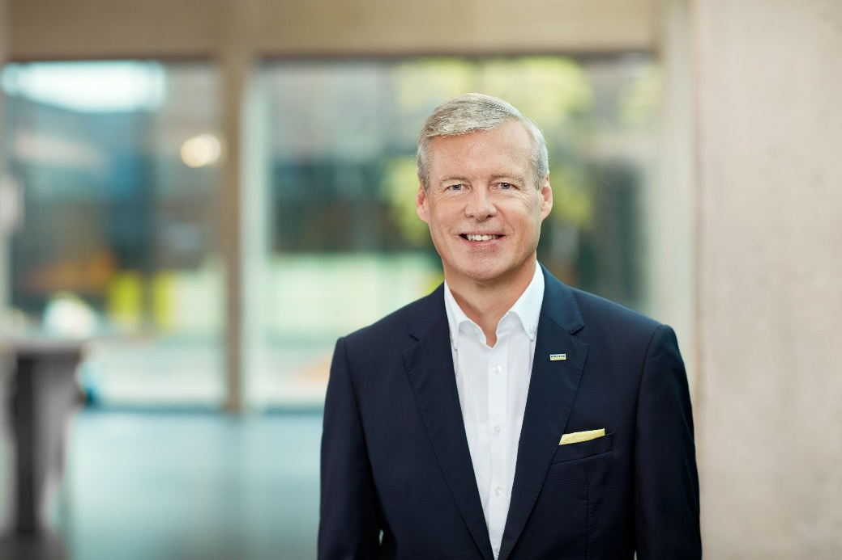
Hartmut Jenner, Chief Executive Officer and Chairman of the Board of Management at Alfred Kärcher SE & Co. KG.

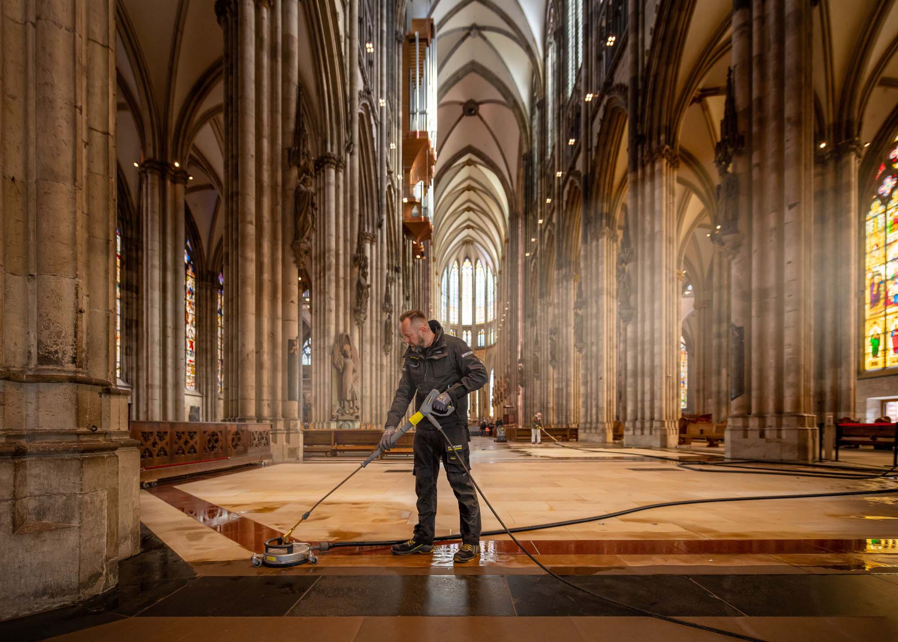
As part of a cultural sponsorship programme, Kärcher restored and cleaned the spectacular sandstone and mosaic floor in Cologne Cathedral.

