Kärcher gives tips for watering the garden with rain water

Water on!

Press Contact
Moritz Dittmar
Press Officer
Alfred Kärcher SE & Co. KG
Alfred-Kärcher-Str. 28-40
71364 Winnenden
Tel. +49 71 95 14-3919
moritz.dittmar@de.kaercher.com
Kay-Uwe Müller
Press agency: Tschorn & Partner
Postfach 10 11 52
69451 Weinheim, Germany
Tel.+49 62 01 5-7878
mueller@pressebuero-tschorn.de
Winnenden, May 2020 – First, there's so much rain that the earth can't soak it all up and then it stays very dry for several weeks. Again this year, we've got to expect brief, heavy downpours followed by long dry periods. To make sure our gardens don't become arid landscapes, sufficient and regular watering is necessary. Whoever has the opportunity to use water from a well or collect rain water will not only save money, but also conserve resources.

Use rain water for watering
Whoever does not want to use valuable drinking water for the lawn still needn't carry heavy watering cans around. For sprinklers, spray lances or trickle hoses can also be operated with water from wells, cisterns and water butts. The precondition for this is pumps that build up the required pressure.

Barrel pumps are mounted directly onto the edge of the water butt. Alternatively, you can use a garden pump, which can extract water from cisterns easily. There are also Kärcher pumps for narrow deep wells that are placed directly in the water.

How does the water get to the plants?
The many different types of garden plants have very varied water requirements. But which watering method is suitable for which type of plant?

On lawns, sprinklers distribute the water evenly in fine drops. Square or rectangular sprinklers have a greater range, and the advantage is that the water can be distributed precisely up to the edges and in border areas.

Spray guns allow targeted watering with exact dosing of the water quantity. Spray guns with which various spraying patterns can be selected are particularly practical. Thus, depending on requirements, you can change without any trouble between large-area sprinkling, fine spray mist or a powerful water stream.

Spray lances provide a larger range than spray guns. Thanks to the long lance and its mobile sprinkler head, the watering of difficult-to-access areas in flower beds or under hedges is easier.

Watering systems both work according to requirements and are at the same time convenient. By means of the exactly positioned spraying and drip nozzles or with a bead hose, the plant roots can be reached in a very targeted manner. In combination with water timers, the watering can be individually controlled. Among other things, in this way you can set when and on which days watering should begin and how long it should go on for.

Tips for a green garden
The best time for watering the garden is in the morning/before midday. Water can seep into the ground slowly when temperatures are still low and plants can absorb it in the midday heat – which is when they need it most.

Watering plants from the top is quicker, but most plants are unforgiving of this – flowering plants and vegetables in particular prefer being watered close to the ground. Plants with dense foliage, such as roses, will often develop fungal diseases when leaves do not dry quickly enough.

For watering, the maxim is: Greater quantity rather than more often. If watering is done occasionally, yet always generously, water can seep deeper into the soil. This encourages plants to develop longer roots, which helps them overcome dry spells better.

Sprinklers, spray lances or trickle hoses can also be operated with water from wells, cisterns and water butts. The consumption of valuable drinking water can thus be significantly reduced.

Barrel pumps are mounted directly onto the edge of the water butt.

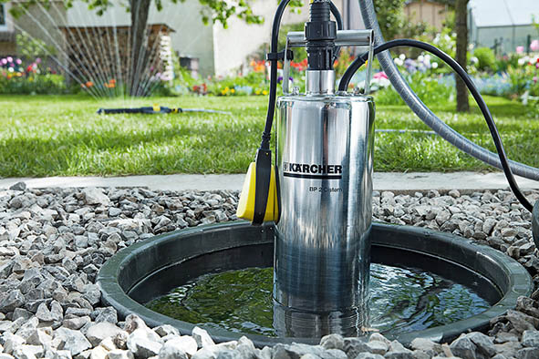
There are submersible pumps for narrow deep wells that are placed directly in the water.

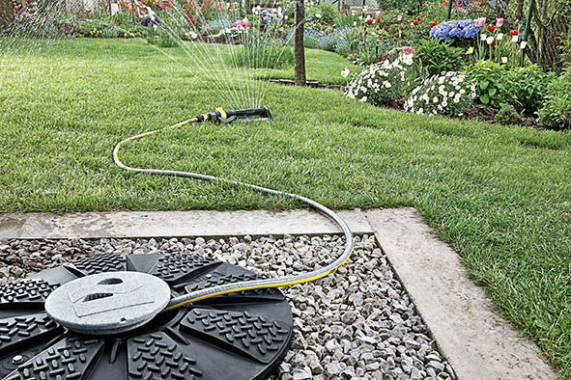
On lawns, sprinklers distribute the water evenly and in fine drops. The water required can be pumped from the cistern or a well.

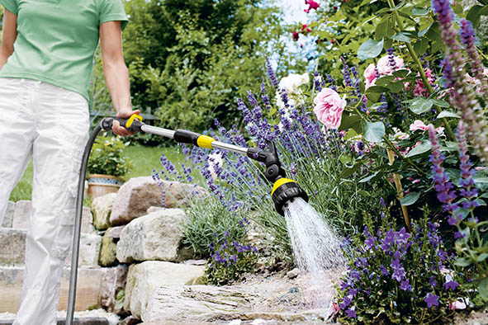
Spray guns and sprinkler lances allow targeted watering with exact dosing of the water quantity.

