New certification for professional steam cleaners

Fighting viruses with water steam

Press Contact
Nina Effenberger
Public Relations
Alfred Kärcher SE & Co. KG
Alfred-Kärcher-Str. 28-40
71364 Winnenden
Tel. +49 71 95 14-5503
nina.effenberger@de.kaercher.com
Winnenden, December 2020 – Kärcher has again had the effectiveness of its professional steam cleaners/steam vacuum cleaners tested in connection with viruses. An independent laboratory confirms that, when used properly, the machines effectively eliminate, in addition to enveloped ** viruses such as coronavirus, influenza viruses or HI viruses, also up to 99.99 %* of non-enveloped adeno-, rota- and noroviruses on contaminated surfaces. Not only in times of corona can steam cleaners/steam vacuum cleaners thus ensure the necessary hygiene in the food industry, hotels, supermarkets, care homes, hospitals, offices and public facilities – completely without the use of any chemicals.
The certification
As representative for non-enveloped viruses, test viruses were spread on a PVC surface in two independent test phases. The surface was then cleaned with the floor nozzle of a Kärcher SGV 6/5 steam vacuum cleaner and a SG 4/4 steam cleaner. At maximum steam pressure and a cleaning speed of 30 centimetres per second, a reduction of up to 99.99 % of the test virus was achieved. The disinfectant effect is thus proved and the machines are classified as "limited virucidal PLUS" in accordance with the effective range defined by the Robert Koch Institute. This designation applies to products that can deactivate all enveloped viruses as well as the non-enveloped adeno-, rota- and noroviruses. The effectiveness thus covers the viruses that are particularly often responsible for hospital outbreaks.
Virus deactivation with high temperatures
Viruses such as the SARS-CoV-2 virus or the norovirus may remain infectious for a very long time on hard surfaces such as metal, stone, wood, ceramic, plastic or paper if they are not deactivated. The viruses can be deactivated by high temperatures, among other things, for example with the use of steam cleaners. Already in spring 2020, Kärcher had its steam cleaners successfully tested and certified for their effectiveness in fighting enveloped viruses**.
In this application, hot water steam at over 100 °C is discharged and cools down with increasing distance. In order to combat viruses effectively, the nozzle must be guided over the surface. Before use, other dirt should be removed from the surface. Furthermore, the correct cleaning speed (30cm/s) at the maximum steam stage must be ensured.
Highly effective even without chemicals
Steam cleaners need only electricity and water. As they work without chemical cleaning agents, their use does not harm the respiratory tract of the users. At the same time, potential allergic reactions or changes to the material surface being treated caused by cleaning agent residues are prevented.

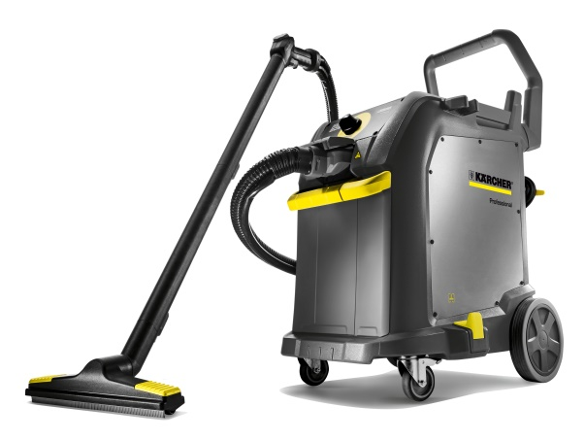
Kärcher has had the effectiveness of its professional steam cleaners/steam vacuum cleaners tested in connection with viruses. The result: The machines are "limited virucidal PLUS" and thus effective for the deactivation of certain enveloped viruses.

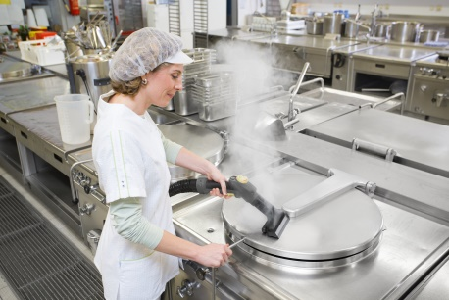
When used properly, the Kärcher professional steam cleaners are proven to eliminate 99.999 %* of enveloped viruses, such as coronavirus, influenza viruses and HI viruses, as well as up to 99.99 %* of non-enveloped adeno-, rota- and noroviruses.

Thanks to the effectiveness in eliminating viruses, the Kärcher steam cleaners are suitable for use in the food industry, as well as in hotels, supermarkets, care homes, hospitals, offices and public facilities

