Kärcher PS 30 Plus power scrubber with swivelling high-pressure nozzle for cleaning corners and edges

Power scrubber with enhanced cleaning

Press Contact
Moritz Dittmar
Press Officer
Alfred Kärcher SE & Co. KG
Alfred-Kärcher-Str. 28-40
71364 Winnenden
Tel. +49 71 95 14-3919
moritz.dittmar@de.kaercher.com
Kay-Uwe Müller
Press agency: Tschorn & Partner
Postfach 10 11 52
69451 Weinheim, Germany
T+49 62 01 5-7878
mueller@pressebuero-tschorn.de
Winnenden, May 2021 – Kärcher is extending its range of accessories for high-pressure cleaning with the new PS 30 Plus power scrubber, which has a swivelling corner- and edge-cleaning nozzle. This nozzle ensures the effective and effortless cleaning of stairs and along edges. As the bristle rink also functions as a splash guard, the user also stays dry during the work.

At first sight, the PS 30 Plus power scrubber, which is connected to a pressure washer during the work, looks like a normal scrubber. In the brush head there are three high-pressure nozzles, which increase the mechanical effect of the bristles many times over and loosen even stubborn dirt without the need for vigorous scrubbing. The new swivelling side nozzle can be positioned so that corners and edges can be reliably reached and cleaned. Via a lip on the front edge of the brush head, the dirty water is then simply and rapidly discharged. In addition, the brush head can be rotated by 360 degrees, thus making hard-to-reach areas more easily accessible.

This new accessory is especially suitable for cleaning stairs, landings and tight intermediate spaces. At the same time, use is not limited to outside areas. At the same time, use is not limited to outside areas. With a working width of 25 centimetres, the power scrubber can also be used in the workshop, cellar or garage, provided that a drain is available.

The power scrubber is available from specialist retail outlets as an optional accessory. The standard plastic HP extension tubes provided are also compatible with other Kärcher accessories for pressure washers. The power scrubber can be used with all types of Kärcher pressure washers (K2 to K7).

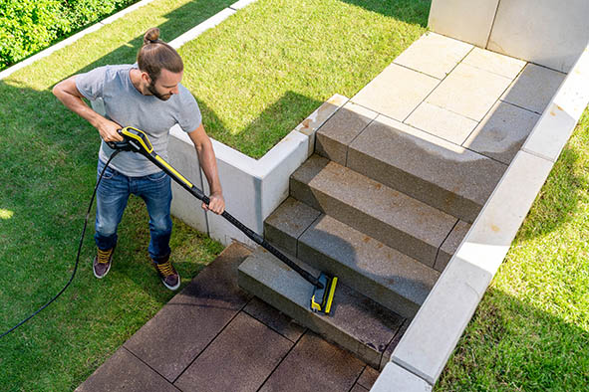
With the new PS 30 Plus pressure washer accessory, the cleaning of stairs and along edges is easier and more effective than previously.

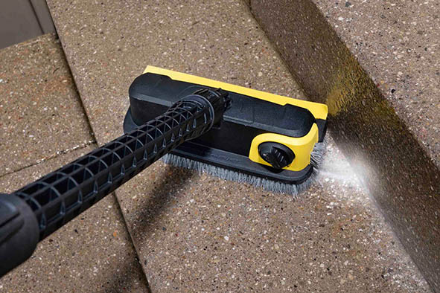
The new PS 30 Plus power scrubber, with a working width of 25 centimetres and a 360-degree rotating brush head, is especially suitable for cleaning stairs, landings and tight intermediate spaces.

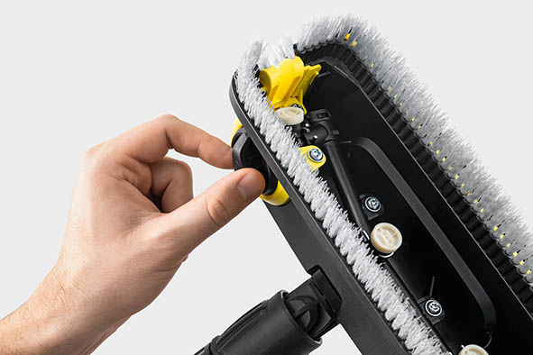
Effective detail: The angle of a side nozzle can be adjusted. Corners and edges can be reached and cleaned with precision.

