Zweistelliges Wachstum in 2021

Kärcher setzt erstmals drei Milliarden Euro um

Pressekontakt
Anouk von Hochmeister
Pressereferentin
Alfred Kärcher SE & Co. KG
Alfred-Kärcher-Str. 28-40
71364 Winnenden
T +49 71 95 14-2168
anouk.vonhochmeister@de.kaercher.com
Winnenden, 14. Februar 2022 – Kärcher hat 2021 zum ersten Mal in der Unternehmensgeschichte die Umsatzschwelle von drei Milliarden Euro innerhalb eines Geschäftsjahrs überschritten. Mit insgesamt 3,092 Milliarden Euro Umsatz konnte der Reinigungsspezialist den letztjährigen Rekord um 13,6 Prozent übertreffen. Der Erfolg ist dabei gleichmäßig auf alle Regionen und Produktgruppen verteilt. Währungsbereinigt wuchs Kärcher in den beiden Corona-geprägten Jahren ganze 25 Prozent. Auch die Mitarbeiterzahl ist mit über 900 Neuzugängen im letzten Jahr deutlich angestiegen: 14.400 Beschäftigte arbeiten jetzt in 150 Firmen und 78 Ländern für das Familienunternehmen aus Winnenden.
„Kärcher ist 2021 außergewöhnlich gewachsen – in einem Jahr, das kaum herausfordernder hätte sein können“, sagt Hartmut Jenner, Vorsitzender des Vorstands der Alfred Kärcher SE & Co. KG. „Die gravierenden Einschränkungen durch Corona, vor allem die teils drastischen Verwerfungen in der Lieferkette – bei den Transporten, die Materialknappheit und die rasant angestiegenen Rohstoffpreise – haben uns sehr viel abverlangt. Nur die harte engagierte Arbeit aller Beschäftigten in sämtlichen Unternehmensbereichen hat das Geschäftsjahr für Kärcher so erfolgreich gemacht.“ Als Dank erhielten alle Mitarbeiter zum wiederholten Mal Corona-Prämien; insgesamt über sechs Millionen Euro gingen allein an die Belegschaft in Deutschland.
Hohe Nachfrage in allen Produktbereichen
Seit Beginn der Pandemie ist der Privatkundenbedarf an Hochdruckreinigern, Dampfreinigern und Gartengeräten von Kärcher gestiegen; Lockdowns, vermehrtes Homeoffice und ein allgemein erhöhtes Hygienebedürfnis haben zu dem Trend beigetragen. Im zweiten Jahr unter Corona-Bedingungen hat auch die Nachfrage nach Geräten für den professionellen Einsatz wieder deutlich angezogen und das strategische Gleichgewicht zwischen den beiden Kärcher-Geschäftseinheiten wiederhergestellt. Vor allem in Industrie und Gastgewerbe wurde weltweit wieder mehr in Maschinen investiert – von Saugern über Dampfreiniger bis hin zu Bodenreinigungsgeräten.
Die zentrale Produktneuheit im Endkundensegment war 2021 eine Hochdruckreiniger-Serie mit App-Anbindung via Bluetoothschnittstelle (Smart Control Range). Im professionellen Anwendungsbereich zahlten die Neuheiten auf den Ausbau der Akku-Plattform Kärcher Battery Universe ein: Mit der CVS 65/1 brachte Kärcher seine erste Teppichkehrsaugmaschine heraus – als einziges Modell am Markt verwendet sie einen Lithium-Ionen-Akku. Die Scheuersaugmaschinen erhielten Zuwachs von zwei kleineren Modellen, BR 30/1 und BR 30/4, die die Lücke zwischen manueller und maschineller Reinigung schließen, sowie von der großen Aufsitz-Scheuersaugmaschine B 110.
Kärcher Futuretech konnte im vergangenen Jahr zwei Großaufträge gewinnen, die sich auf einen knapp dreistelligen Millionenwert summieren: Die niederländische Armee bestellte ein großes Kontingent an Wasserversorgungssystemen, die deutsche Bundeswehr mobile Ausrüstungssätze. Hartmut Jenner fasst zusammen: „2021 war ein Jahr, das uns nach vorne gebracht hat; wir sind deutlich stärker als der Reinigungsmarkt gewachsen.“
Hohe Investitionen in die eigene Zukunft
Während sich das Unternehmen im operativen Geschäft weiterhin auf Sicht durch die Pandemie und ihre Unwägbarkeiten bewegt, schreitet es zeitgleich in puncto strategischer Investitionen mit großen Schritten voran: „125 Millionen Euro haben wir 2021 in unsere Standorte, Anlagen und vor allem in unsere Mitarbeiterinnen und Mitarbeiter investiert – immer mit Blick auf den Kundennutzen. So gestalten wir die Zukunft von Kärcher und bilden die Grundlage für weiteren Geschäftserfolg“, sagt Hartmut Jenner.
60 Millionen Euro davon flossen in drei deutsche Standorte: Im Logistikzentrum Obersontheim im Kreis Schwäbisch Hall werden aktuell das Hochregallager erweitert und die bestehenden Lagerkapazitäten verdreifacht, das benachbarte Werk Bühlertal, Kärchers größter und modernster Produktionsstandort, wird umfangreich ausgebaut und im Main-Tauber-Kreis entsteht ein neues, zentrales Service Center, in dem die Wartung und Reparatur von Produkten aus zehn europäischen Ländern laufen werden. Weiter wurde beispielsweise in neue Hauptsitze für die Landesgesellschaften in Rumänien und der Ukraine investiert sowie in einen großen Erweiterungsbau für das Werk im rumänischen Curtea des Arges, dem firmeneigenen Kompetenzzentrum für Sauger.
In Themen seiner Zukunft investiert Kärcher auch über die Integration passender Unternehmen in den Firmenverbund: So erweiterte etwa im vergangenen Jahr die Akquisition der spanischen SAP- und Public-Cloud-Beratung 3Hold die IT-Kompetenz der Kärcher-Gruppe. Zu dieser zählt seit 2021 auch die neu gegründete Kärcher Municipal GmbH, die sämtliche Kompetenzen im Bereich Kommunaltechnik unter einem Dach vereint. Das Geschäftsfeld „Wasser und Luft“ bekommt neue Impulse durch eine Beteiligung an dem finnischen Wassersprudler-Start-up Mysoda. Auch für das laufende Jahr sind beträchtliche Investitionen geplant, die avisierte Gesamtsumme übersteigt die letztjährige nochmals deutlich. Eine zentrale Rolle im Jahr 2022 wird mit Sicherheit die Automatisierung als großer Zukunftstrend in der Reinigung spielen. Entsprechende Produktneuheiten dürfen auf den rückkehrenden Fachmessen erwartet werden.
Nachhaltiges Handeln hat viele Gesichter
Dank seiner fest im Unternehmen verankerten Nachhaltigkeitsstrategie durfte sich Kärcher zum Ende des letzten Jahres über zwei weitere Erfolge freuen: die erreichte CO₂-Neutralität aller Werke weltweit und die Auszeichnung mit dem renommierten Deutschen Nachhaltigkeitspreis für einen vorbildlichen Umgang mit Ressourcen. Einen gesellschaftlichen Beitrag leistete der Reinigungsspezialist, als es im Hochsommer darum ging, den flutgeschädigten Menschen in Deutschland und den Niederlanden schnell und unkompliziert zu helfen: Kärcher stellte kurzerhand dringend benötigte Technik im Wert von 250.000 Euro zur Verfügung und schickte eine eigene Feldküche und ein Team von Mitarbeitenden ins Krisengebiet, um vier Wochen lang dreimal täglich die Hilfsorganisationen vor Ort zu bekochen.
Auch kostenlose Reinigungsaktionen zum Erhalt historischer Monumente sind Teil des umfassenden Nachhaltigkeitskonzepts von Kärcher. Die unternehmenseigenen Reinigungsexperten sind 2021 zum Beispiel an den Kölner Dom gereist, um dort den historischen Sandstein- und Mosaikboden restauratorisch zu reinigen und damit nachhaltig zu schützen. Im französischen Vouglans ist in Zusammenarbeit mit dem Künstler Klaus Dauven ein riesiges Reverse Graffiti auf einer Staumauer inmitten schönster Natur entstanden. Aktuell engagiert sich Kärcher am Obelisken auf der Place de la Concorde in Paris, wo das Unternehmen im Rahmen seines Kultursponsorings nicht nur die komplette Restaurierung finanziell trägt, sondern auch die Reinigung selbst ausführt. Für dieses Jahr ist unter anderem noch ein Einsatz an der Christusstatue in Rio de Janeiro geplant.

Eine Word-Datei und druckfähige Bilder zu dieser Presseinformation liegen für Sie in unserem Newsroom https://www.kaercher.com/presse zum Download bereit.

Kärcher-PM_Jahr 2021

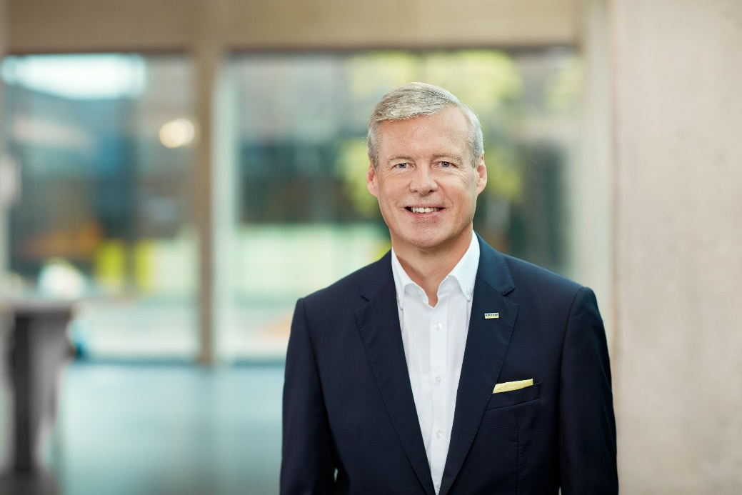
Hartmut Jenner, Vorsitzender des Vorstands der Alfred Kärcher SE & Co. KG.

Mit der neuen Scheuersaugmaschine BR 30/1 bedient Kärcher den Bedarf nach maschineller Unterstützung für die Reinigung kleiner Bodenflächen.
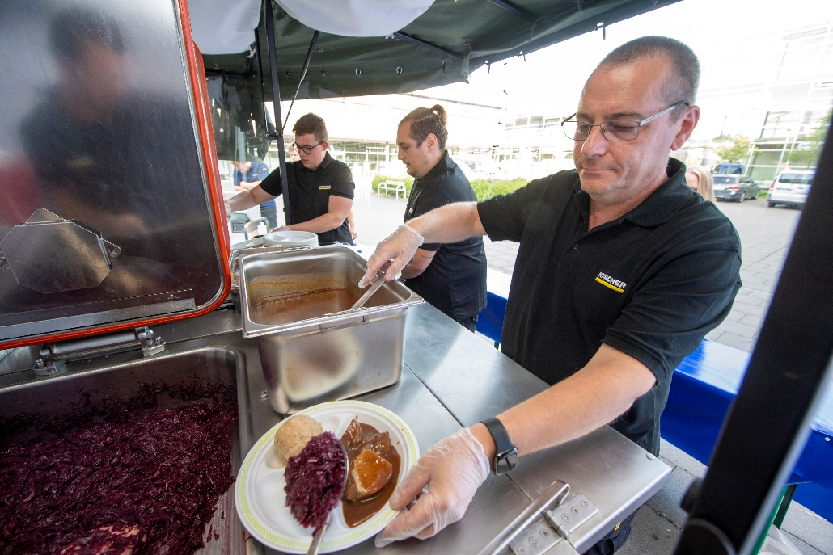
In einer Feldküche von Futuretech versorgte ein Kärcher-Team im flutgeschädigten Ahrtal wochenlang die Helfer mit täglichen Mahlzeiten.

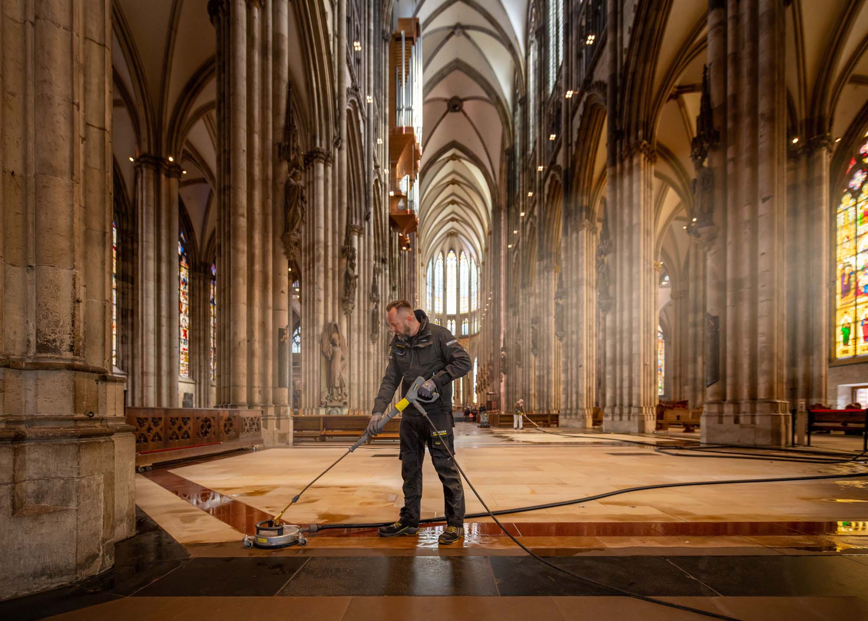
Im Rahmen seines Kultursponsorings hat Kärcher den beeindruckenden Sandstein- und Mosaikboden des Kölner Doms restauratorisch gereinigt.

