Revolutionizing Cleaning Power: Introducing CleanWave, a battery-powered commercial pressure washer by Kärcher
Contact
Robin Paul
Senior Director of Marketing
Kärcher North America
6398 N. Kärcher Way
Aurora, CO 80019
Tel. +1 303-788-9020
robin.paul@karcher.com

Aurora, CO, January 9, 2024 – In a ground-breaking move towards sustainable and efficient cleaning solutions, Kärcher, the global market leader for cleaning solutions, proudly unveils its latest innovation: CleanWave, a battery-powered commercial-strength cold-water pressure washer. Engineered to meet the demands of professional cleaning tasks by partnering power with environmental responsibility, this cutting-edge washer redefines the landscape of commercial cleaning equipment. A testament to Kärcher's commitment to innovation and sustainability, CleanWave is designed for professionals who demand top-tier performance and lead environmental stewardship.

The battery-powered CleanWave Deluxe is equipped with advanced lithium-ion technology with a runtime of up to 4 hours. The CleanWave Classic model is also available, featuring AGM batteries with a runtime of up to 1.5 hours. The cordless design means the operator is not tethered to a power source, unlike conventional electric models.

Designed for versatility, this state-of-the-art pressure washer caters to a spectrum of applications, from outdoor spaces and building exteriors to heavy machinery and industrial equipment. CleanWave can be positioned in a facility’s wash bay, or placed on a truck or trailer, allowing more mobility for cleaning professionals to work efficiently without constraint.

Moreover, the eco-conscious design aligns with Kärcher's commitment to sustainability. By eliminating reliance on fossil fuels and minimizing carbon footprint, this battery-powered washer embodies our dedication to environmentally responsible solutions without compromising on productivity. With CleanWave, being a good steward for the planet aligns with eliminating fossil fuels from your cleaning operations.

KEY FEATURES:
Cordless Freedom: Liberating cleaning professionals from the constraints of electrical cords, this pressure washer allows users to navigate seamlessly through various job sites without sacrificing power.

Eco-Friendly Operation: The battery-powered design aligns with Kärcher's commitment to environmental sustainability. By eliminating the need for traditional fuel sources, our pressure washer not only reduces carbon emissions and contributes to a cleaner planet, it saves approximately $5,000 in fuel costs annually when compared to gas-powered pressure washer usage.

Extended Battery Life: Equipped with advanced battery technology, the CleanWave Deluxe delivers maximum power for up to 90 minutes and maximizes productivity in ECO mode for up to an astounding 240 minutes of solid cleaning time. The L-ion battery pack can recharge from flat to full in 10 hours.

Robust Construction: Delivering robust cleaning performance without compromise and built with durability in mind, CleanWave features a rugged steel cage design and a forklift compatible frame, ensuring it stands up to the demands of commercial use. State-of-the-art controls ensure the motor and pump are protected throughout extended use, even in hostile environments up to 110°F.

Versatile Applications: From construction sites to industrial facilities, fleet maintenance to outdoor cleaning projects, CleanWave is designed to meet the diverse needs of commercial cleaning. CleanWave rides the wave of innovation to propel us towards a cleaner, greener future with zero emissions.

The Clean Wave battery-powered commercial cold-water pressure washer by Kärcher is set to revolutionize the cleaning industry by offering a powerful and eco-friendly alternative to traditional cleaning equipment. For more information, product specifications, and purchasing details, visit www.karcher.com/us.

 | CleanWave  Deluxe | Deluxe in  ECO Mode | CleanWave Classic
GPM | 3.5 | 2.0 | 2.0
PSI | 4000 | 2000 | 2000
Volts | 72 | 72 | 36
Max Runtime | 90 mins | 240 mins | 90 mins
Full Charge Cycle | 10 hrs | 10 hrs | 8 hrs
Pump | Direct | Direct | Direct

Alfred Kärcher SE & Co. KG is the world's leading provider of cleaning technology. The family-owned enterprise employs more than 13,000 people in 72 countries and more than 127 subsidiaries. Kärcher North America is one of the largest subsidiaries with over 1,100 employees. In the United States, Kärcher produces and distributes products and services under the brands Kärcher, Landa, Hotsy, Water Maze and Legacy. The company’s solutions serve customers‘ cleaning needs in an economical and environmentally-friendly manner. Visit www.karcher.com/us for more information.

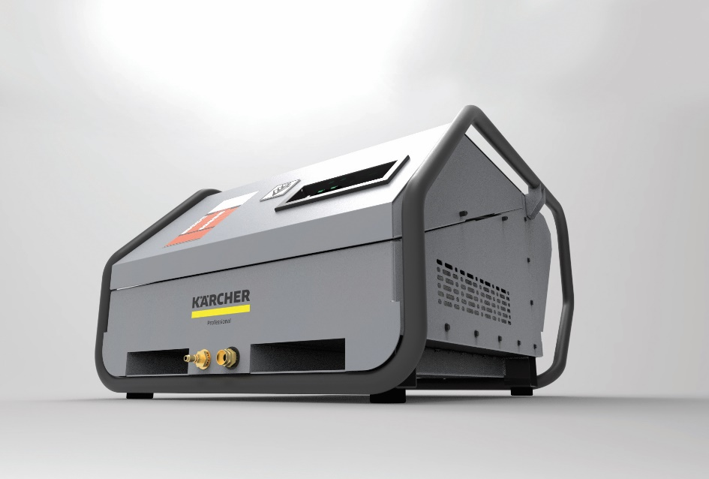

Welcome to the cleaning revolution. CleanWave commercial battery-powered pressure washer propels us towards a cleaner, greener future with zero-emissions.

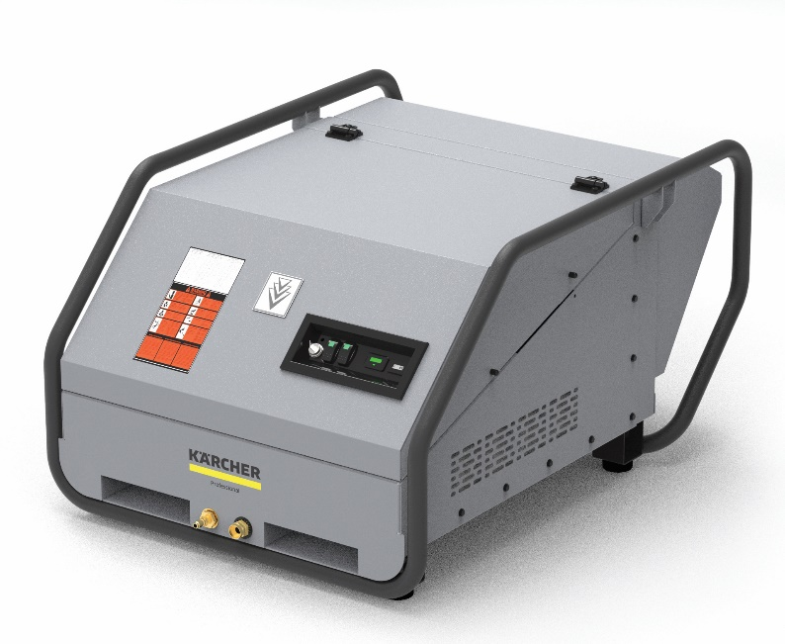
CleanWave, unleash the power without the cord with an unrivaled runtime of up to 240 minutes.

