

* Monitor and manage customer orders’ Professional team and follow up with PIC (Logistic team) - inventory of fast movers to ensure stock availability, block products in order to achieve a smooth order processing and delivery and target customer service level.
* Highlight to sales team slow mover of machine while offering customer similar items for stock clearance and up sales strategy (if any).
* Assist to dispatch PO and all signed & chopped documents for Hanoi & Danang branches and double-check selling price for Dealer team.
* Manage and prepare all documents such as signed & chopped PO, CO, CQ, Warranty card, Payment Request, INV, Contract Liquidation Minutes, bidding documents, products demo for Professional team and any requirements.
* Back up team-mates and sales admin in Hanoi & Danang branches when workload makes this necessary.
* Other duties as assigned and report to CS Supervisor
* **Your qualifications include**
* At least 1-year experience as secretary, sales admin or customer service
* English: good level
* Good communication
* Ability to present, persuade, negotiate well
* Customer oriented
* Good in MS office
* **Our offer for you**

**Kärcher Center Saigon**

Ms. Minh Dang

811A-811B, Truong Chinh,

Tay Tanh, Tan Phu, HCM

Tel: +84-28-381-000-55 #132

* **Your contact**

Here is how to get your career off to a fast start: Send your completed documents to our Human Resources department via email:

[hr@vn.karcher.com](mailto:hr@vn.karcher.com)

* A secure job with flexible time models.
* Above-average employee benefits and company pension scheme.
* A motivational working atmosphere with plenty of flexibility, freedom and personal responsibility.
* A unique work environment, where the emphasis is on the compatibility of your family and work life.
* Individual development / further training measures and attractive career paths.
* A wide range of benefits: food, health, sport and culture.
* **Your tasks include**

Kärcher leads the market in

cleaning systems, products and

services; representing quality,

innovation and sustainability.

We owe this success to our

personnel, who demonstrate

their commitment every day

on behalf of our company and

our products.

As a family owned organisation,

with well-developed corporate

structures, we can offer   
exceptional career prospects. Interesting challenges and   
opportunities for knowledge transfer provide a perfect   
platform for your individual career planning and personal development.

We are looking for committed

staff that value teamwork   
and can, together with us,   
deliver what makes Kärcher special – always providing the best, without exception.

* 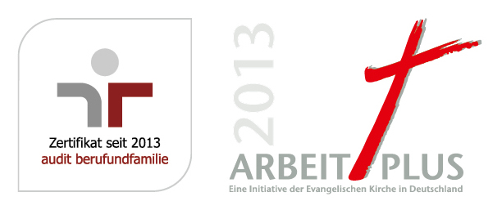

Customer Service Executive (Sales Admin)

Extraordinary tasks call for extraordinary people. We look forward to your dedicated

support of our Customer Service department at our Kärcher Center Saigon