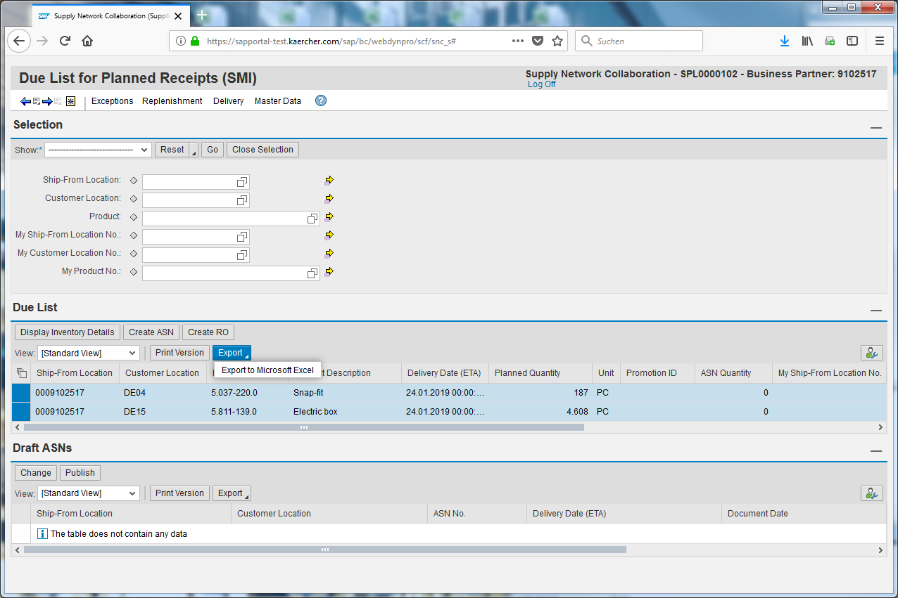
In this E-Learning you see how to export this data into Excel.
Open the Due list for Planned Receipts (Delivery > Receipts and Requirements> Due list for Planned Receipts.
To upload the data successful into your ERP there is the possibility to export the data from SNC into Excel.
Click the button to select all entries.
Click the Select All input field.
Click Export.
Click the Export to Microsoft Excel input field.
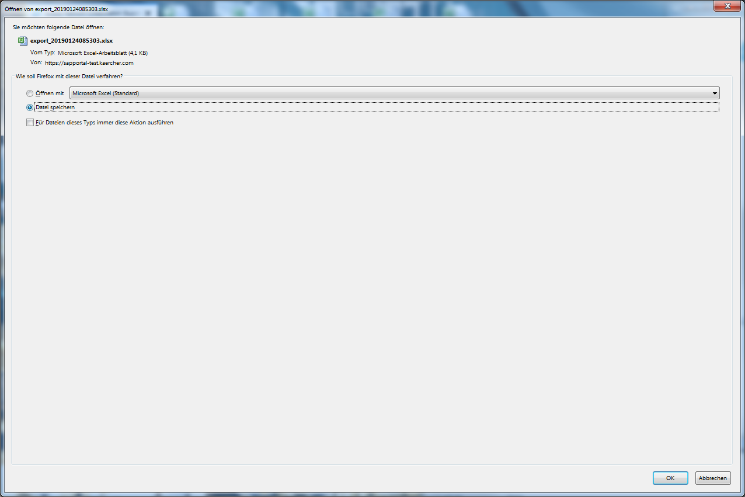
Click the button Save Data.
Click the OK button. Afterwards you can select a path where the Excel sheet will be saved.

