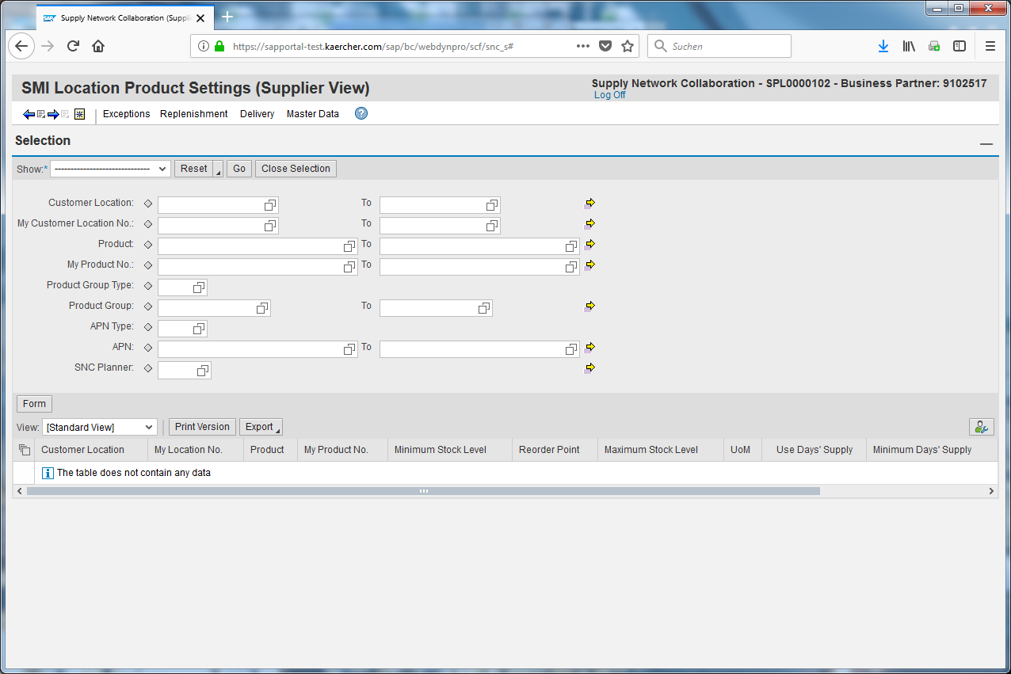
Click on the selection field Product.
In nearly every overview you have to choose selection paramters to find the data you need. It is helpful to create a selection which can just be selected every time you need.
The first thing you have to do therefor is to select the parameters like for example the product.
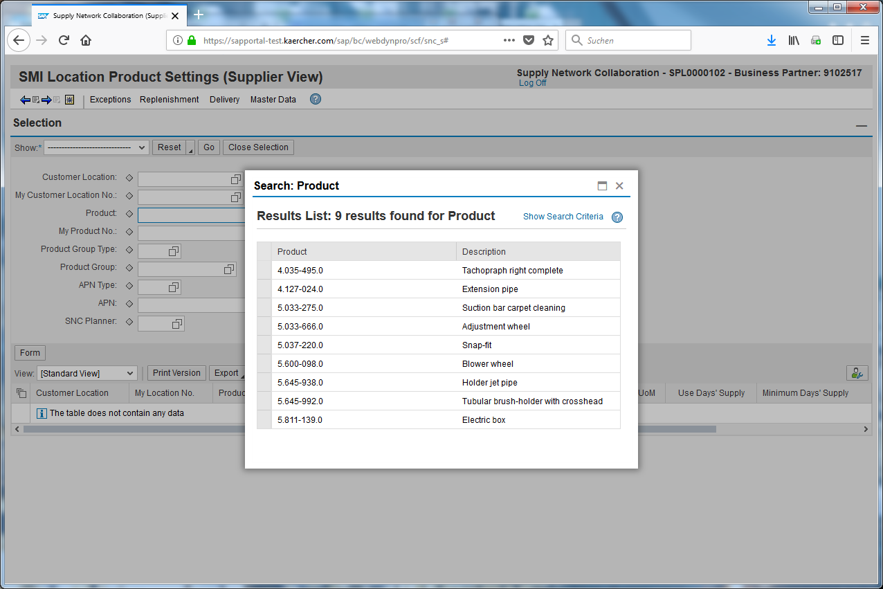
Choose the product you want to select.
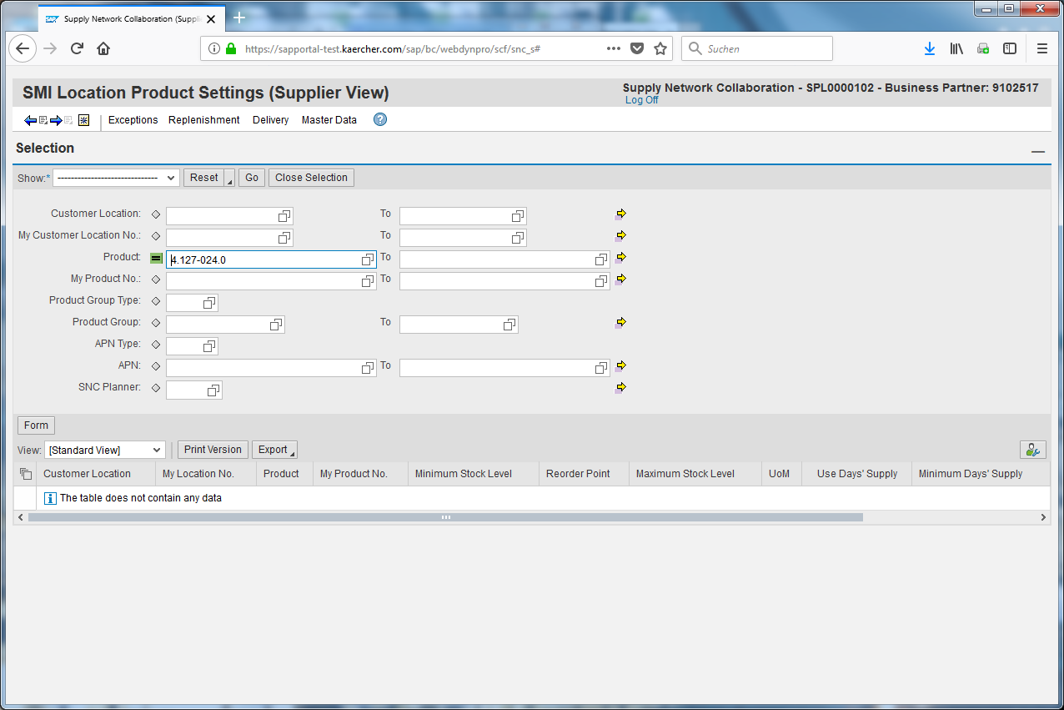
Double-click the Advanced Options image.
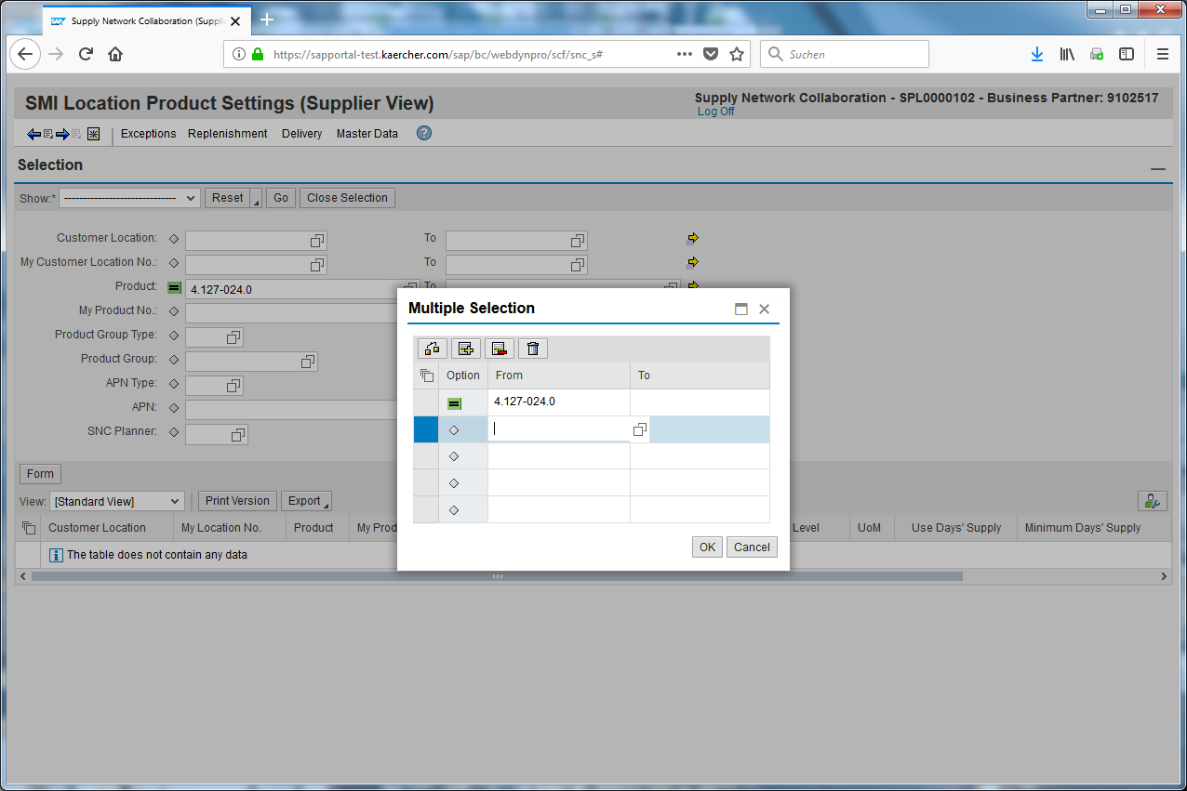
You can now insert a second product to add it to the selection.
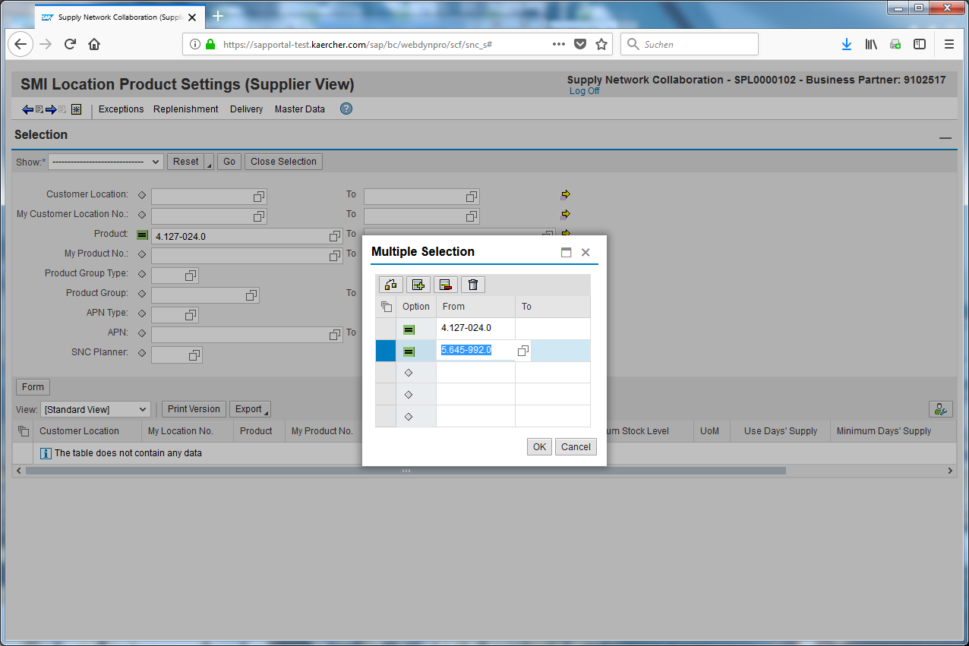
When you have inserted all of your products you can save it with okay.
Click the Save as... input field.
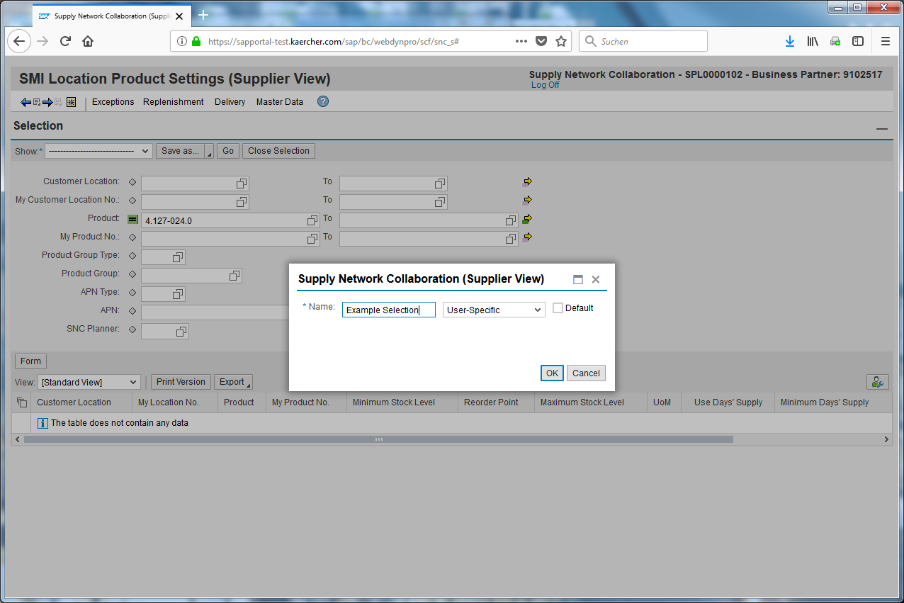
Enter the name (Example Selection) into the input field.
You should choose a name which describes the selection best to refind it later.
Click .
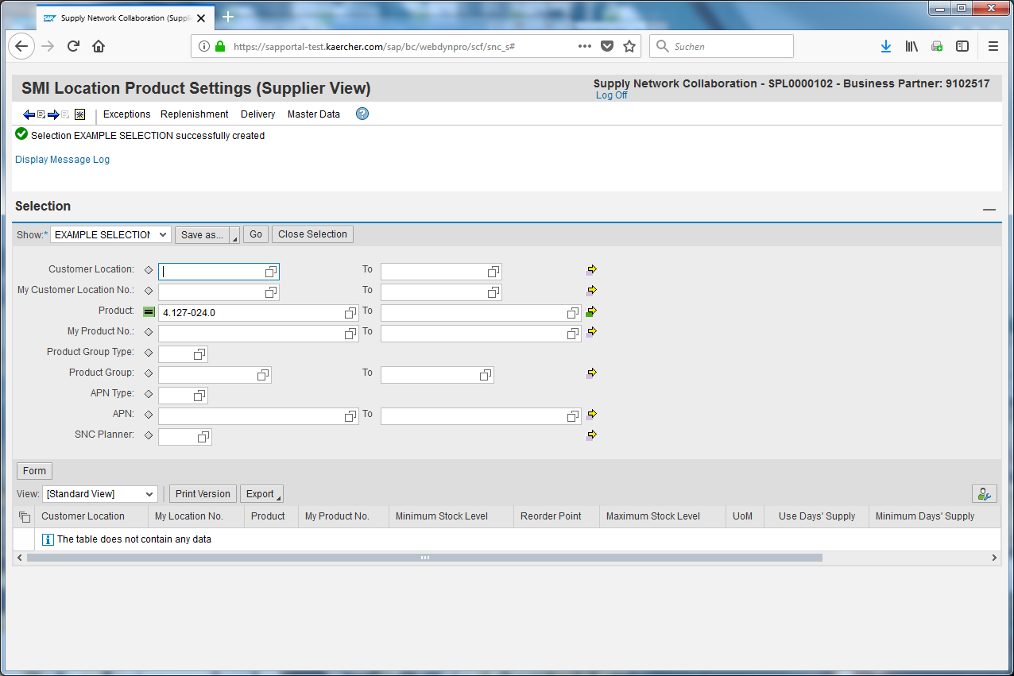
Click .
The selection was saved successfully.
Click the EXAMPLE SELECTION input field.
Now you can just open your selection.
Click Go to execute the selection.
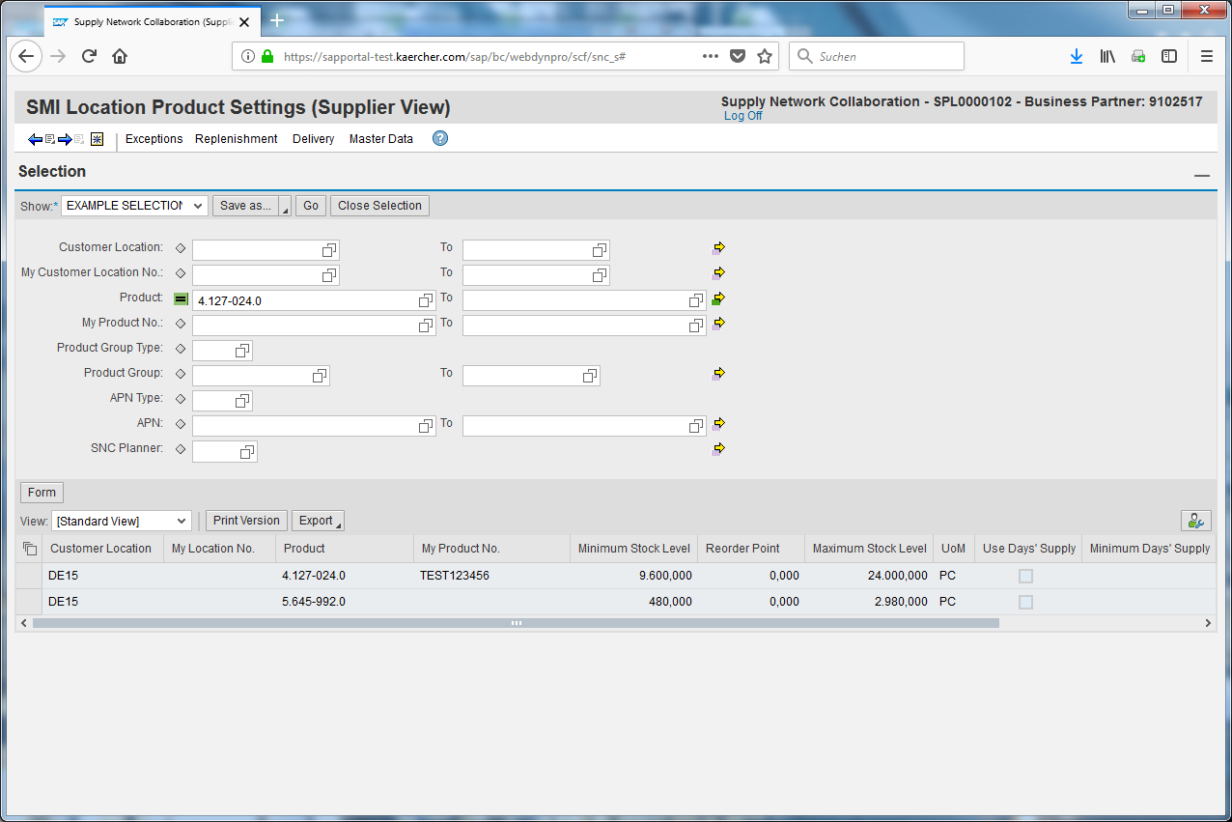
The result of your selection will be shown below.

