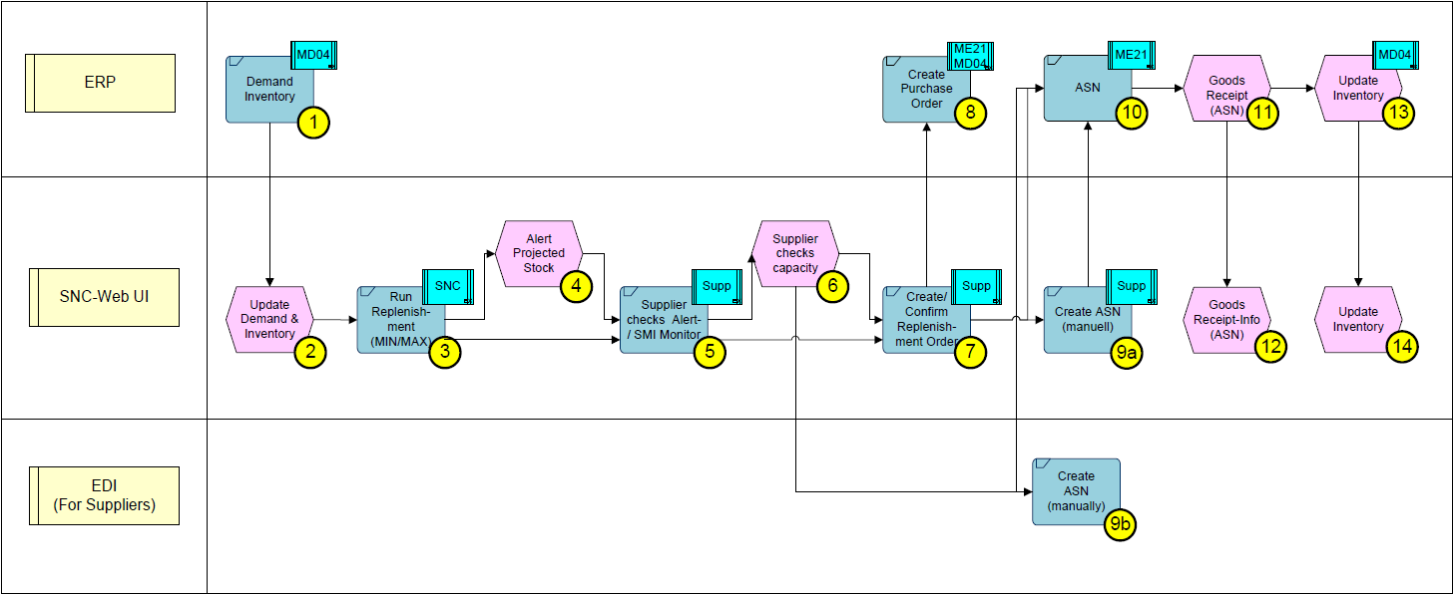
Variant I: Access with the Min/Max-Replenishment Monitor

- This Variant should be used if you have already opened the Min/Max-Replenishment Monitor.
Variant II: Access with the Due List

- This variant should be used if you want to have direct access in the replenishment.
- Variant I
Access with the Min/Max-Replenishment Monitor
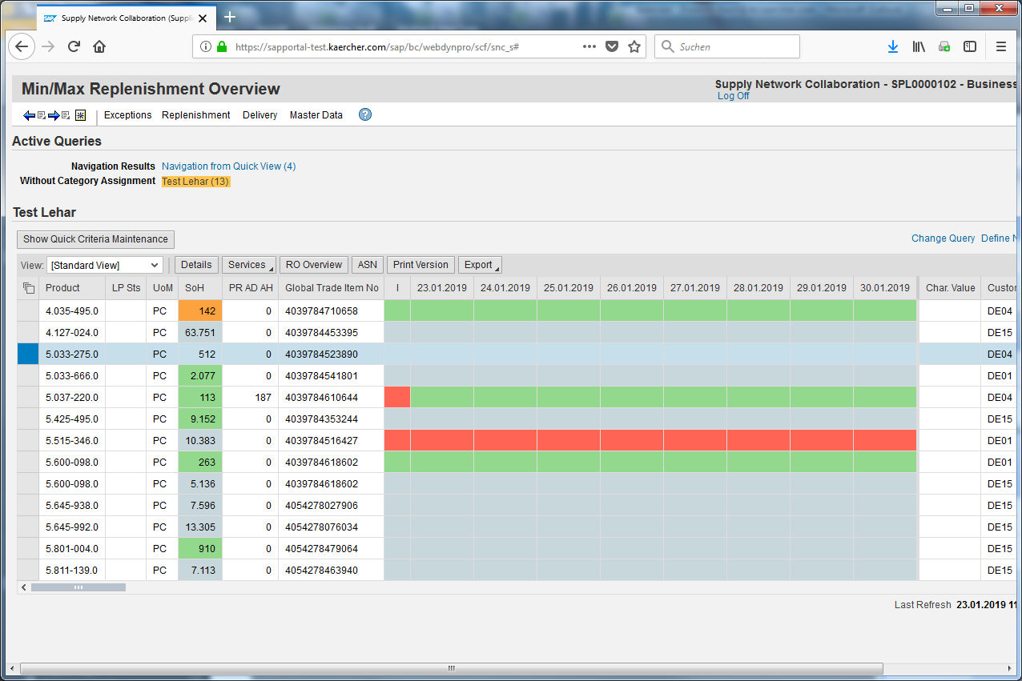
Mark the material you want to work with.
Open the Min/Max-Replenishment Overview (Replenishment > Min/Max-Replenishment Monitor > Min/Max-Replenishment Overview).
The actual situation will be shown in the table below.
Click .
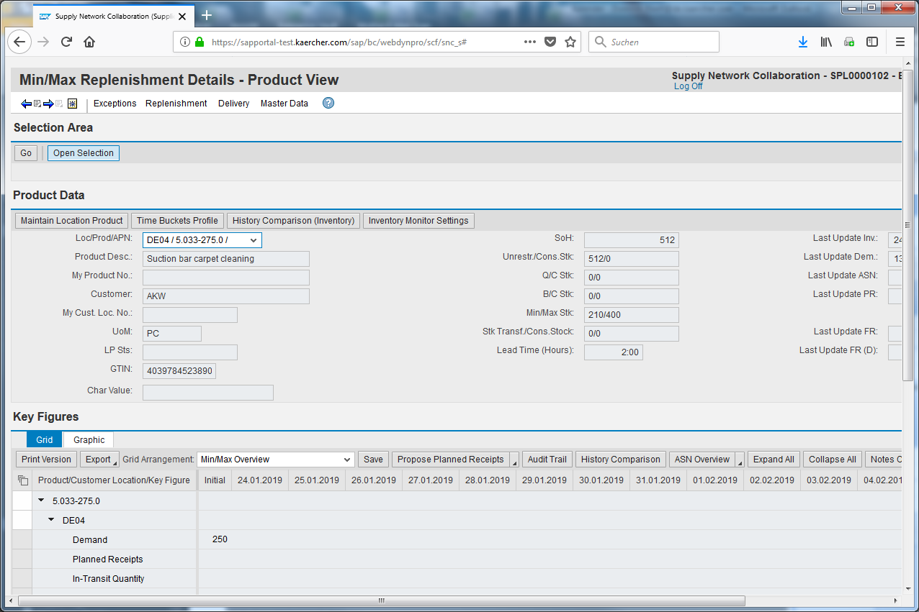
Scroll down.
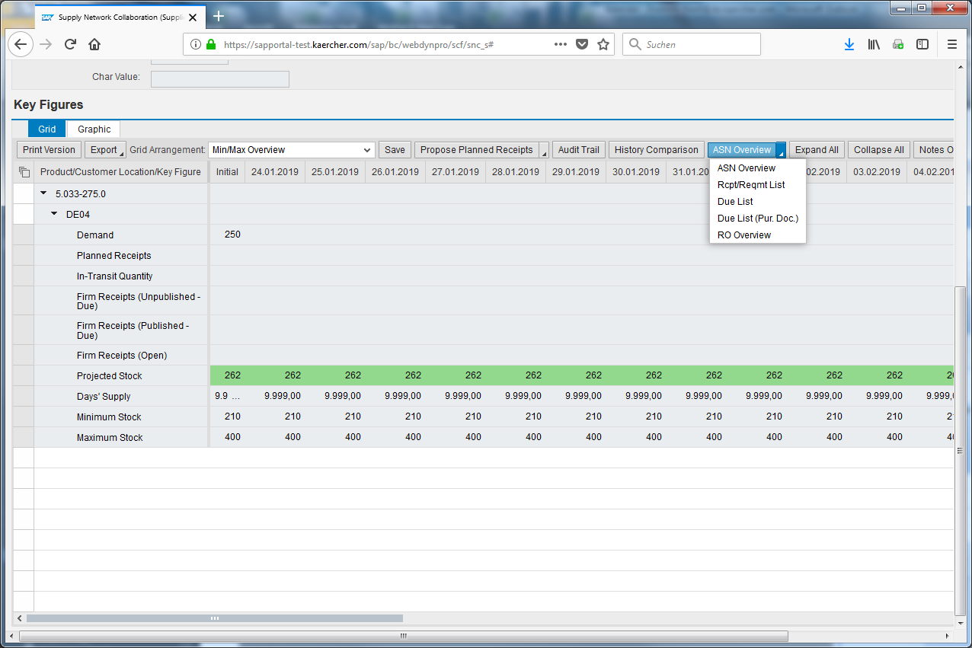
Open the ASN overview.
Click the Due List input field.
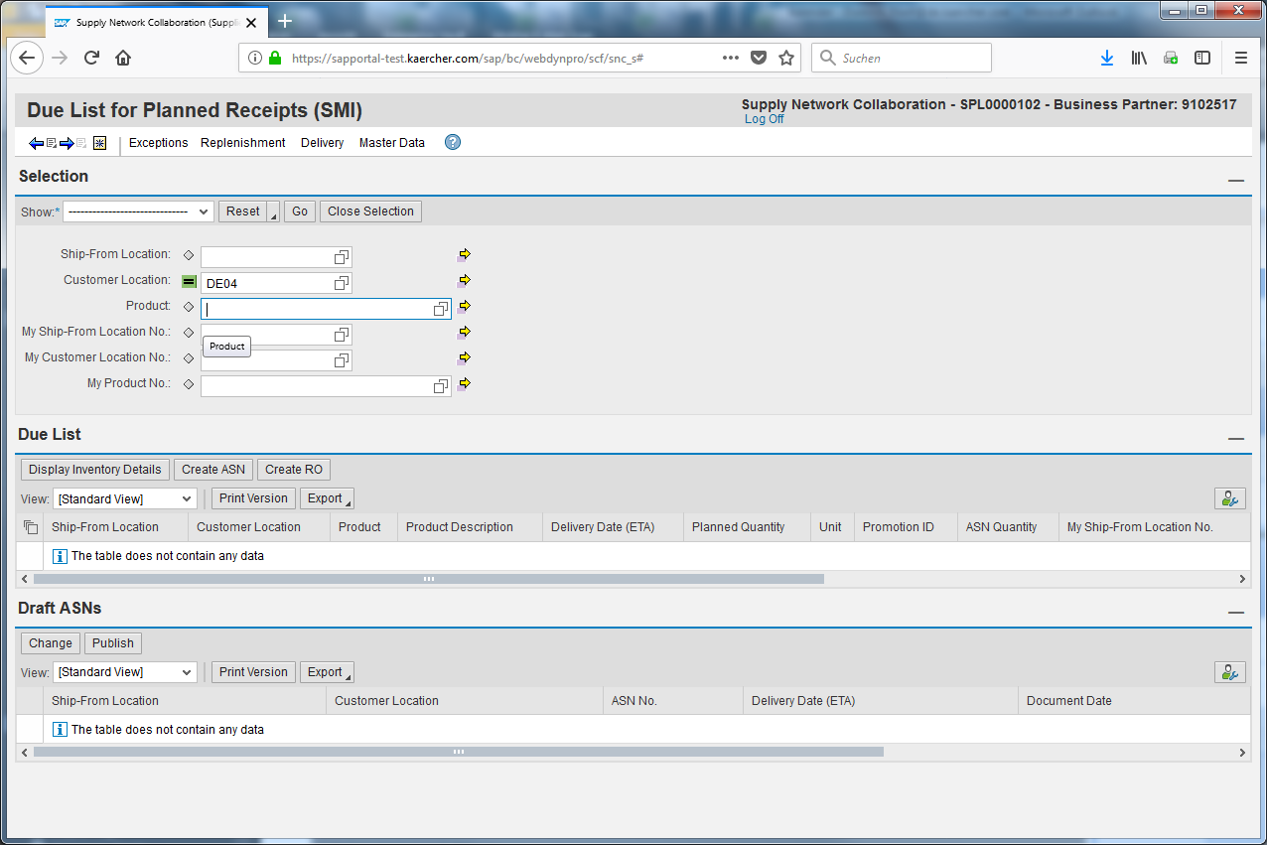
Mark the material.
You can adapt the selection parameters to get different lists.
Delete the value.
Press Enter.
Click .
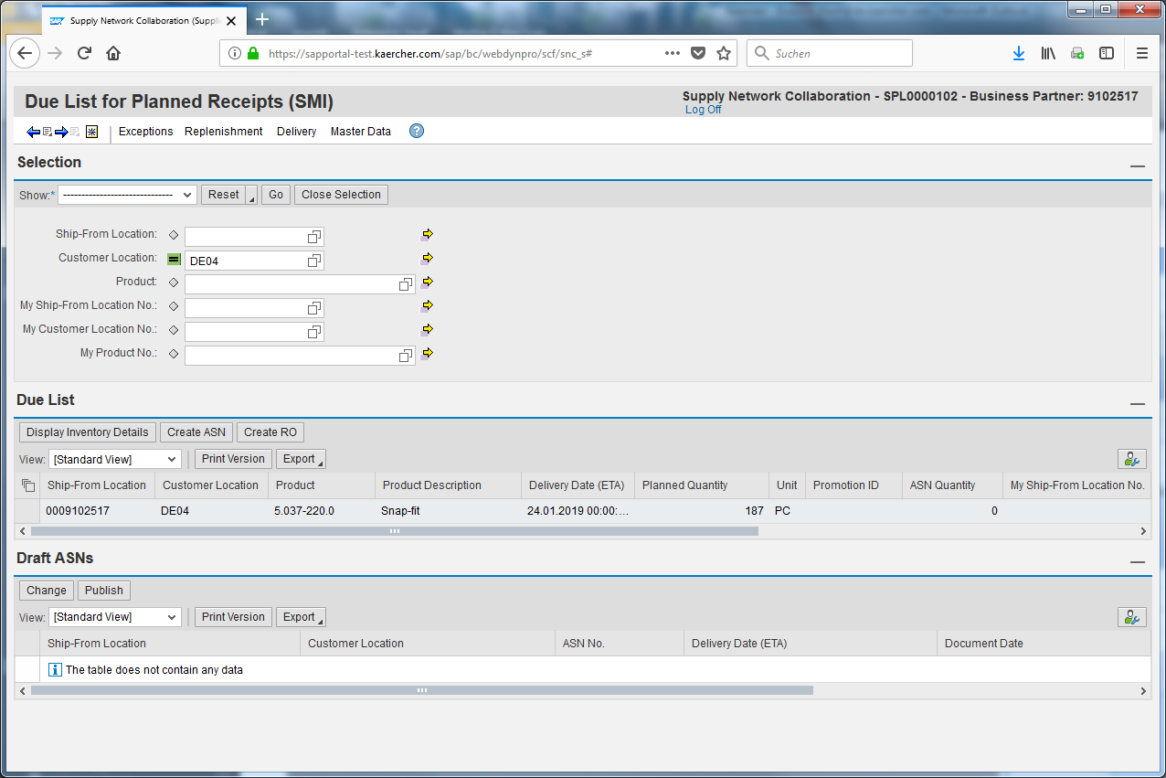
- Variant II
Access with the Due List for planned receipts (SMI)
Go on with the E-Learning.
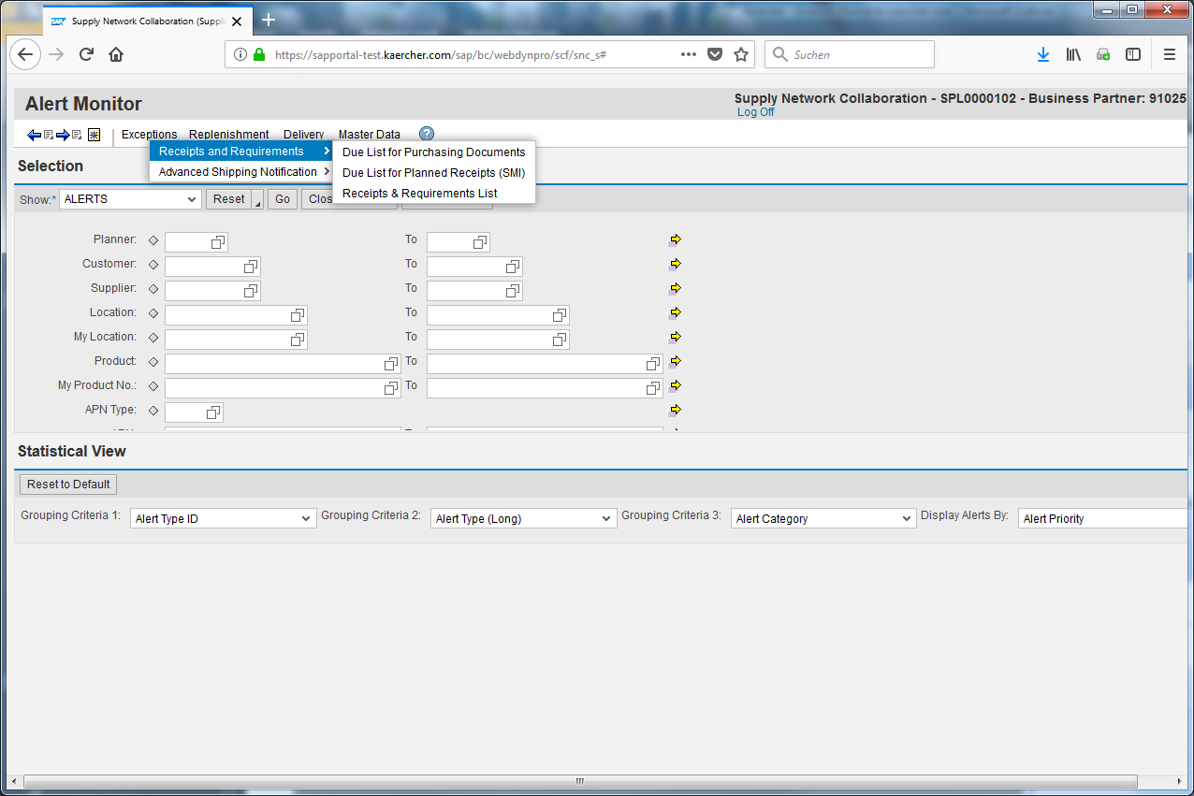
Click the Delivery input field.
Click the Receipts and Requirements input field.
Click the Due List for Planned Receipts (SMI) input field.
After you have adapted the selection click Go.
- Create a Replenishment order
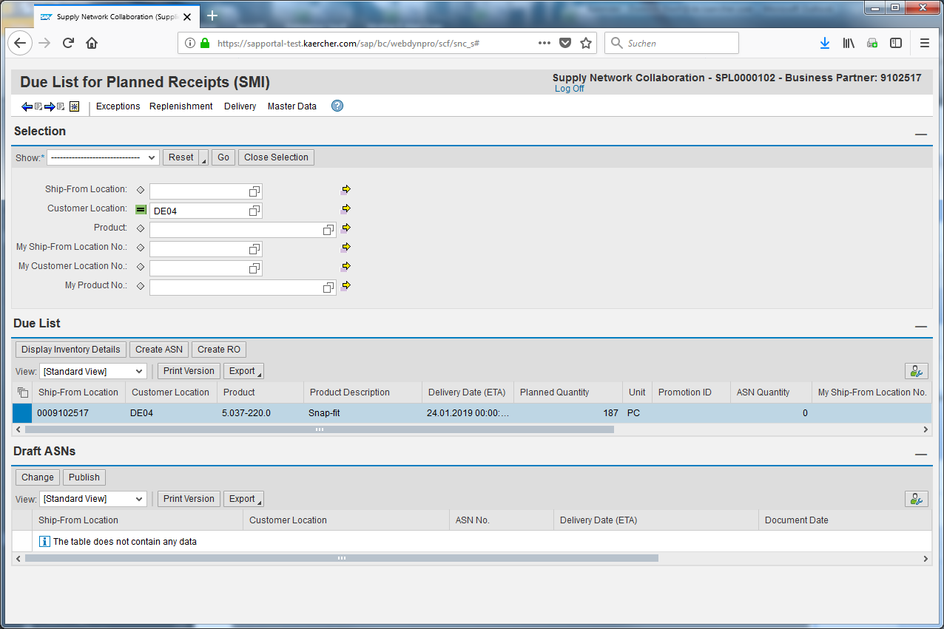
Mark the material you want to work with.
You can select several lines you hold the CTRL-Key.
Click .
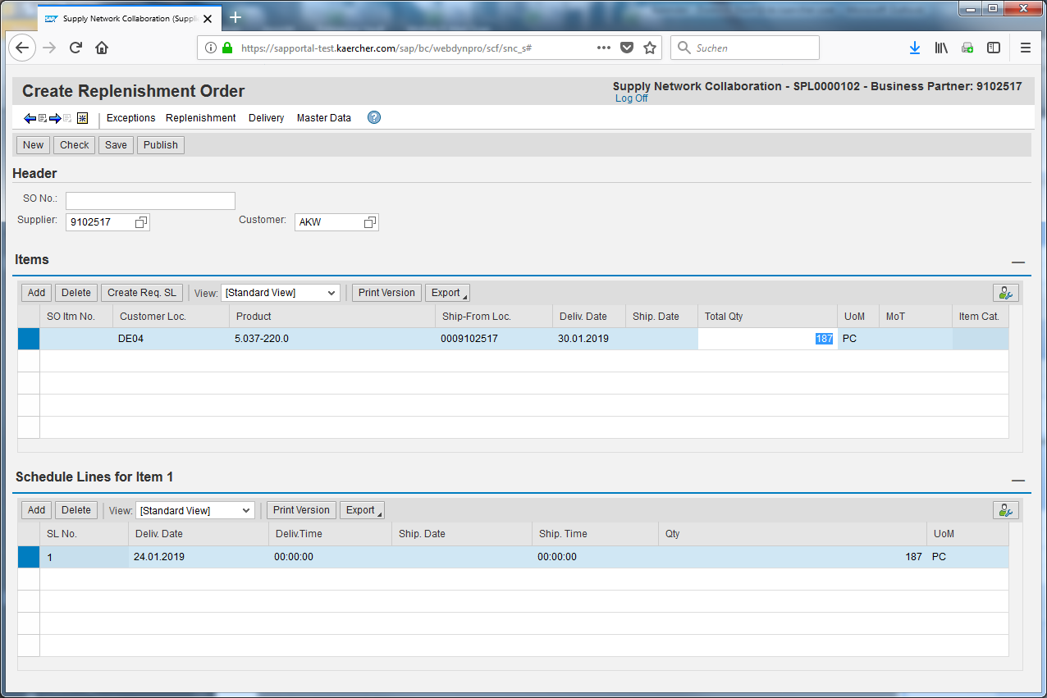
Click .
Adapt the Quantity if needed.
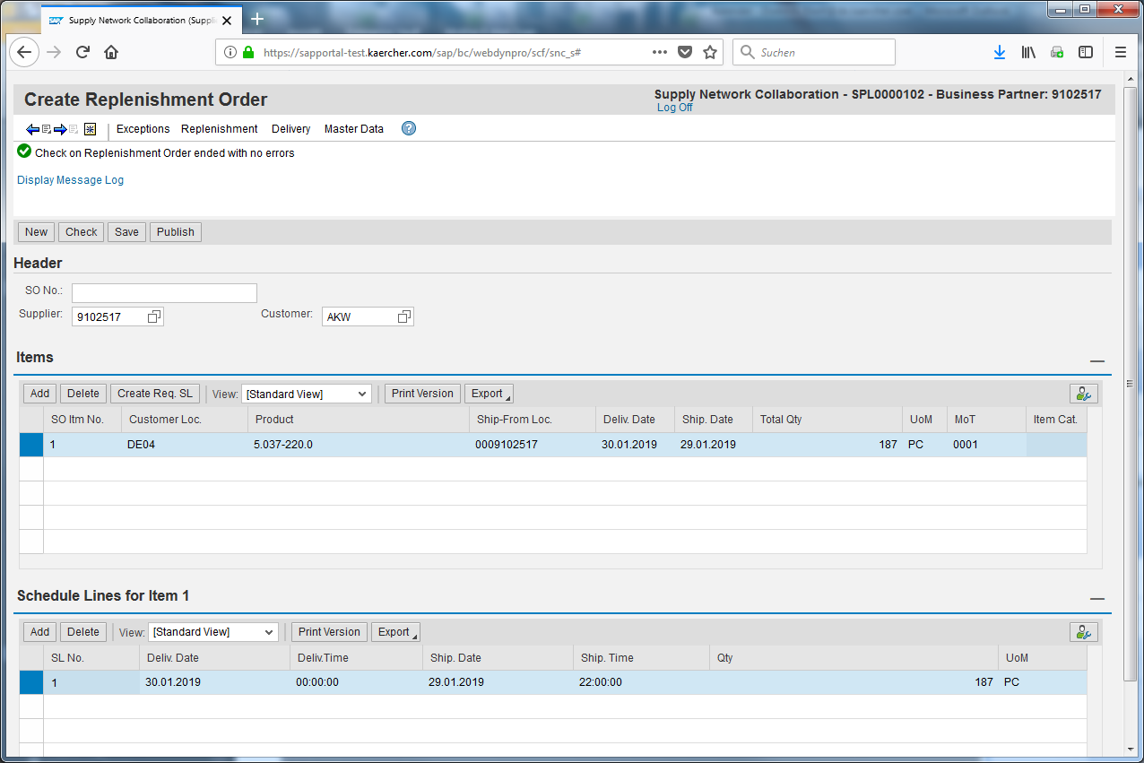
Click .
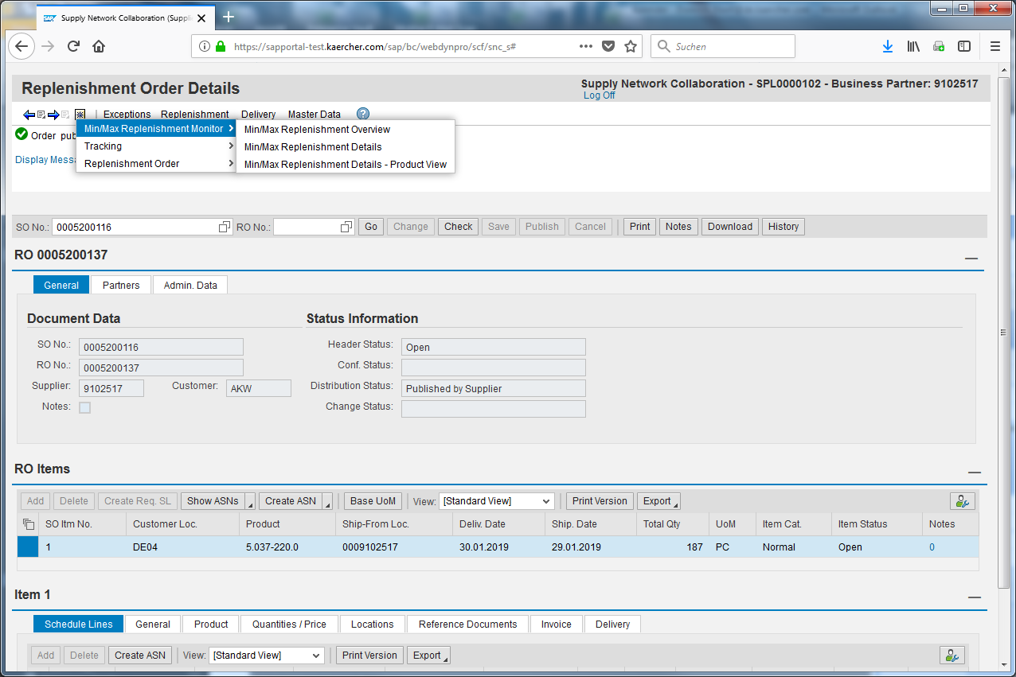
Click the Replenishment input field.
Click the Min/Max Replenishment Monitor input field.
Click the Min/Max Replenishment Details input field.
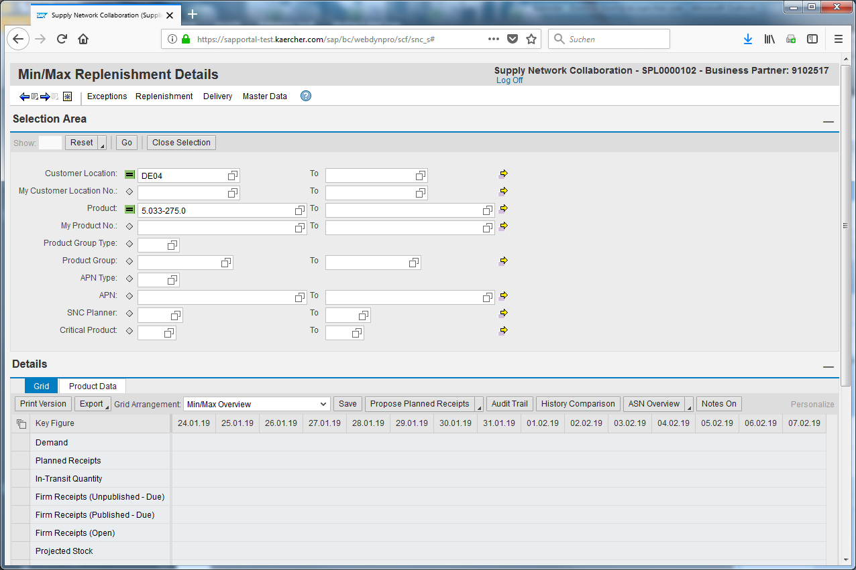
Click the Product Number input field.
Enter your product (5.033-275.0).
Click .
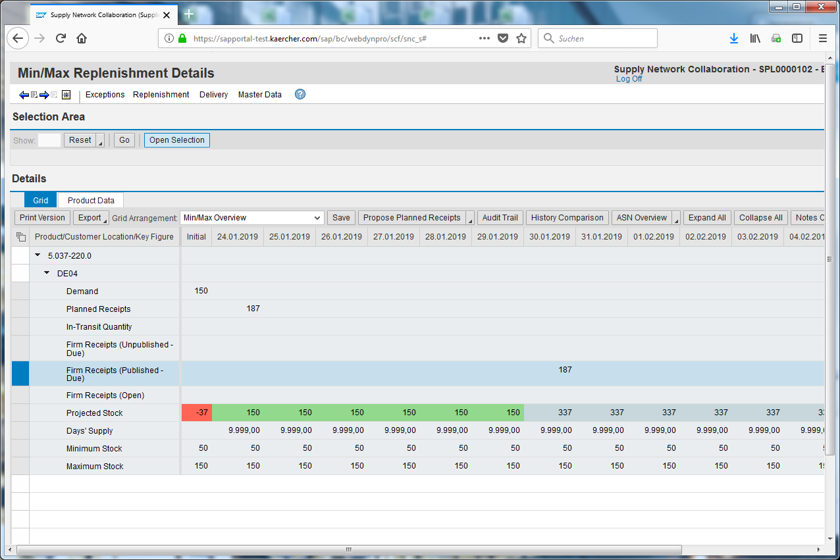
The created replenishment order is listed as Firm Receipts (Published-Due).
If there is more than on order for one delivery date they will be added an represented as Firm receipts.

