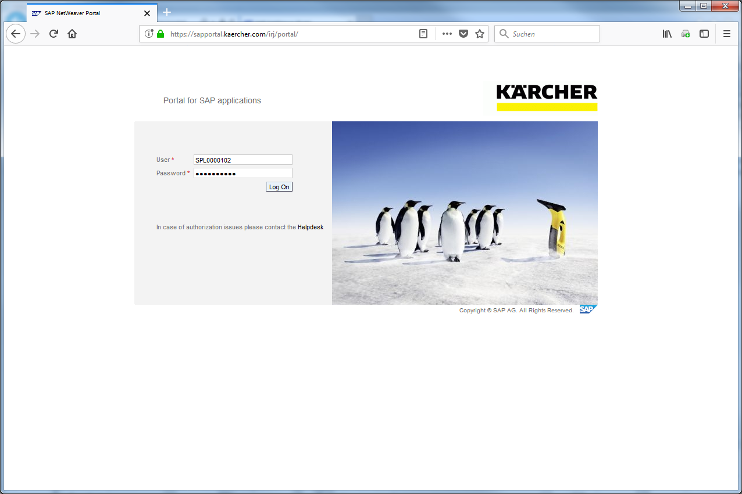
Click the Log On button.
Please open the link https://sapportal.kaercher.com/irj/portal to open the SAP SNC Web GUI.

This example teaches you, how to select the Alert Monitor as your entry screen in future.

Please insert your user and password to login.
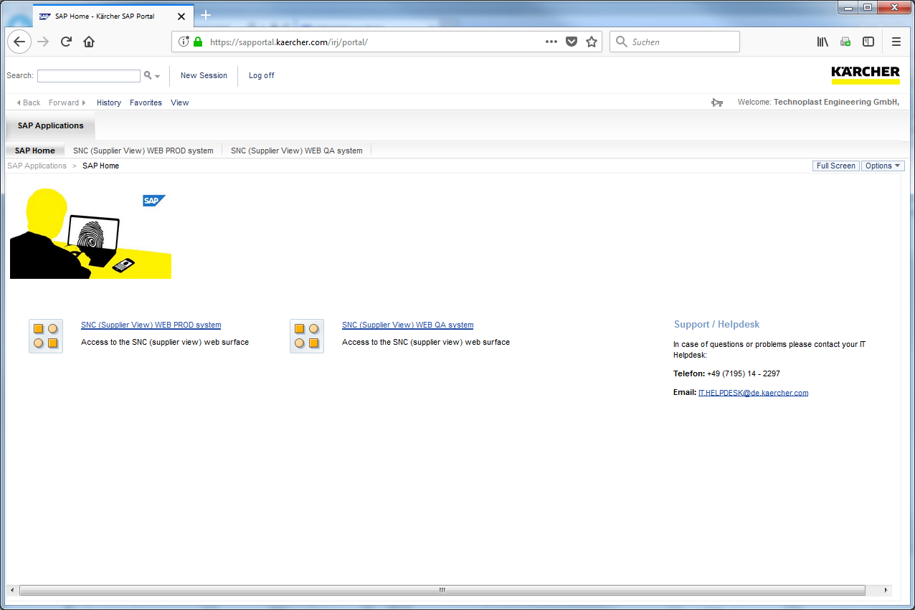
Click the SNC (Supplier View) WEB PROD system hyperlink.
Always use the productive system as shown in the E-Learning.
The QA system should only be used for testing.
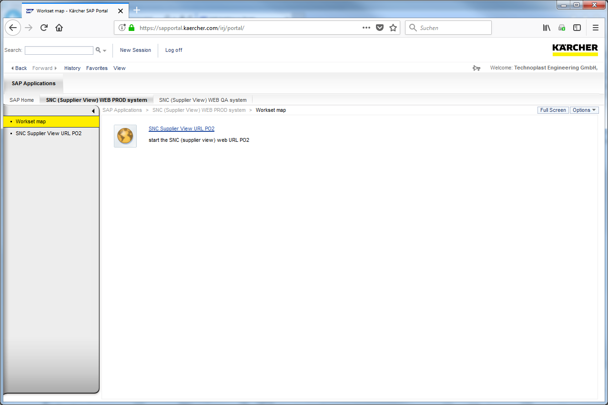
Click the SNC Supplier View URL PO2 hyperlink.
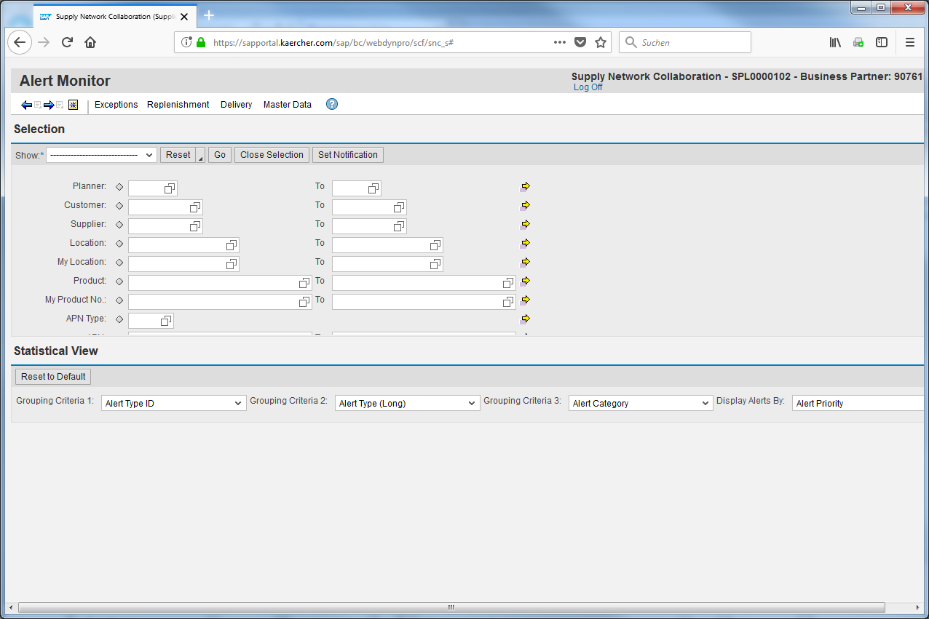
Click the Set Current Screen as Entry Screen Button to save the actual page as your entry screen.
The Alert Monitor shows all actual allerts.
