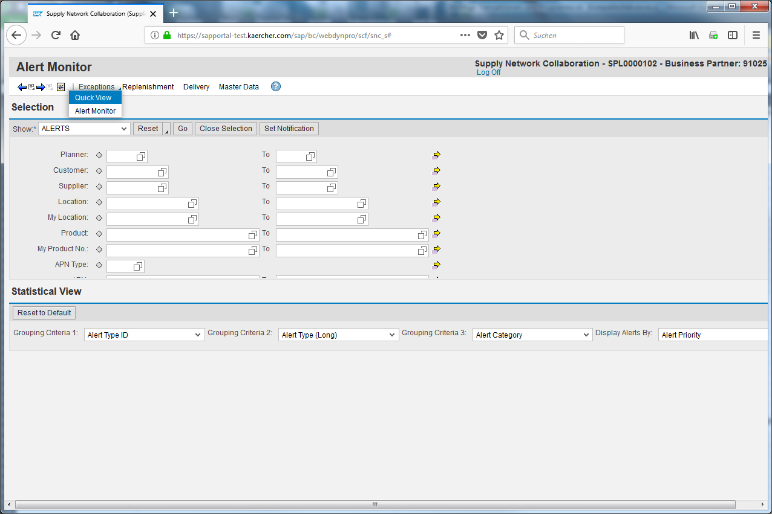
Click the Exceptions input field.
The second possibility to check the alerts is the quick view.
Click the Quick View input field.
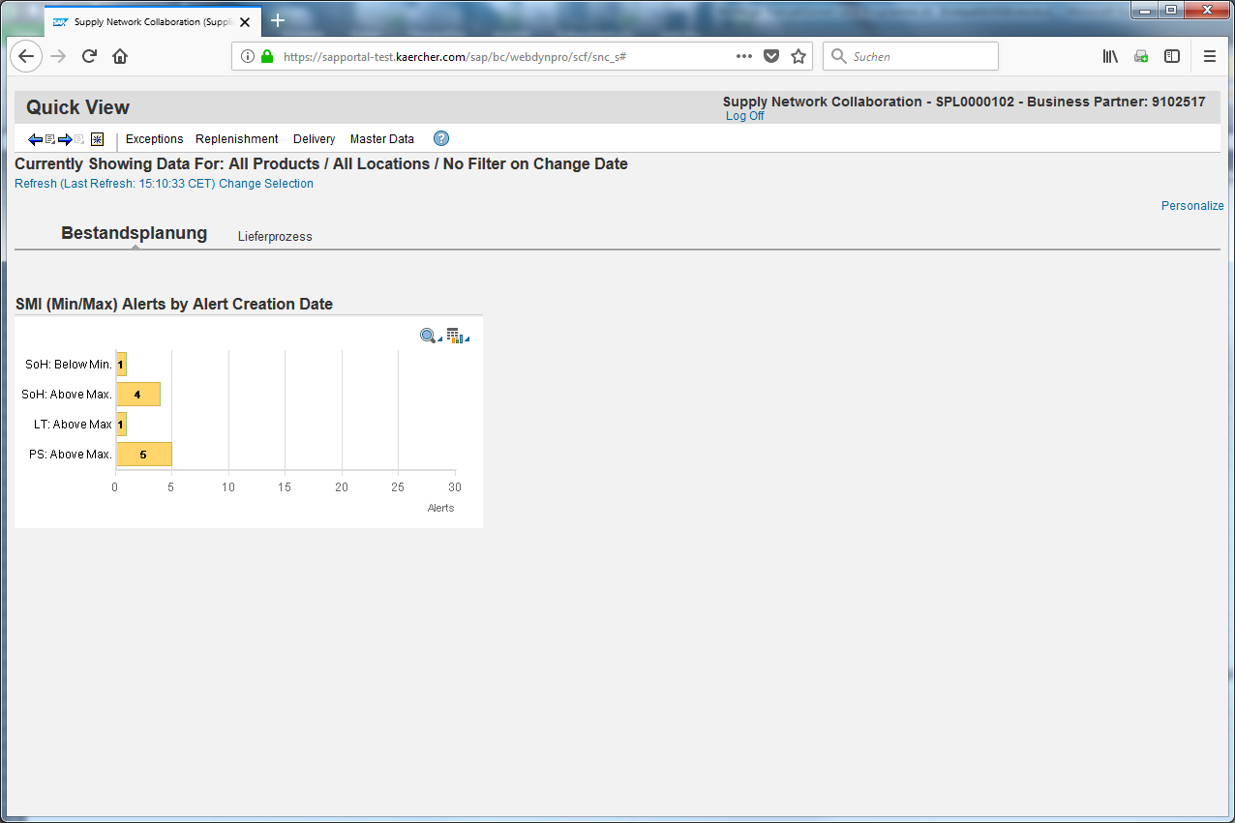
Click on the number next to the alert group you want to see to change to the details.
All alerts are shown in this chart.
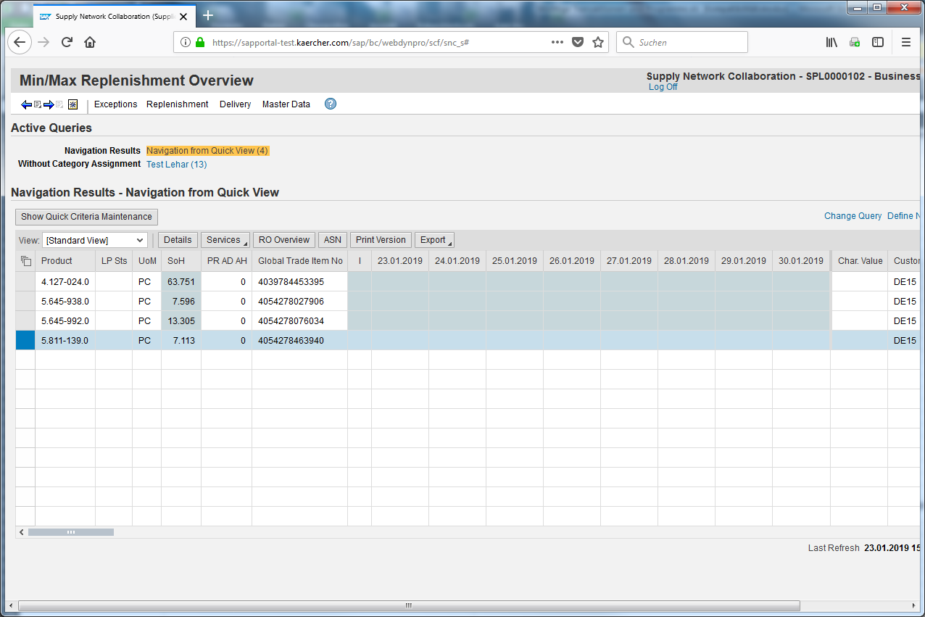
The colours give you feedback about the priority of the alert. Please mark the line you want to check.
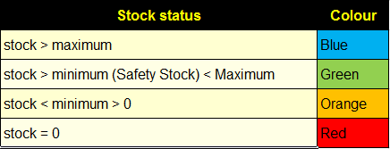
Click Details to open the product view.
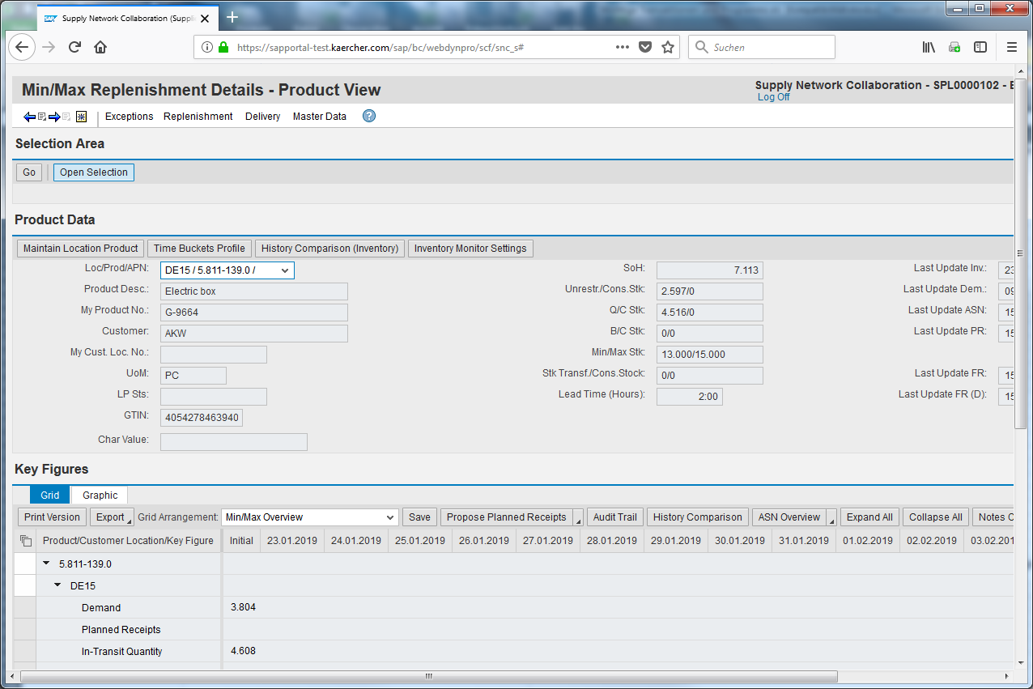
Scroll down.
