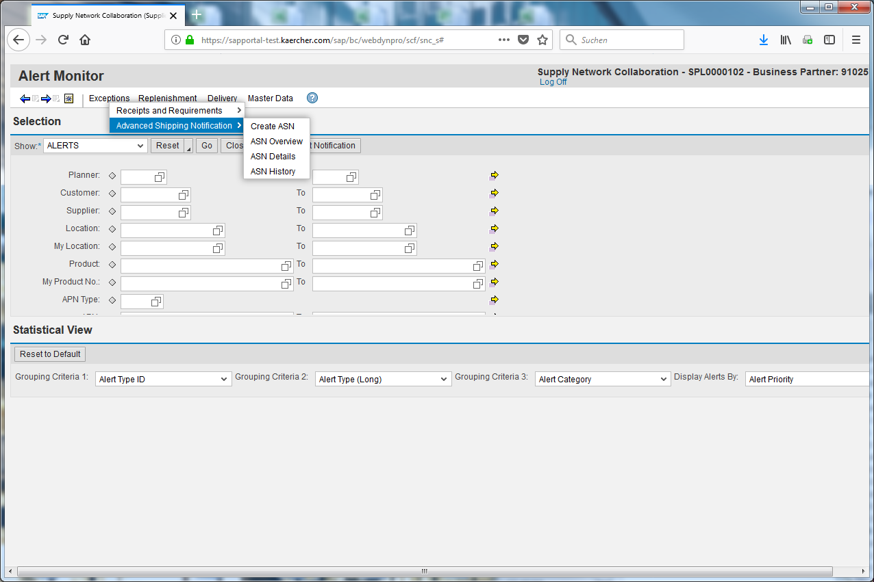
Click the Delivery input field.
This E-Learning teaches you how to open the ASN Overview and create a query.
Click the Advanced Shipping Notification input field.
Click the ASN Overview input field.
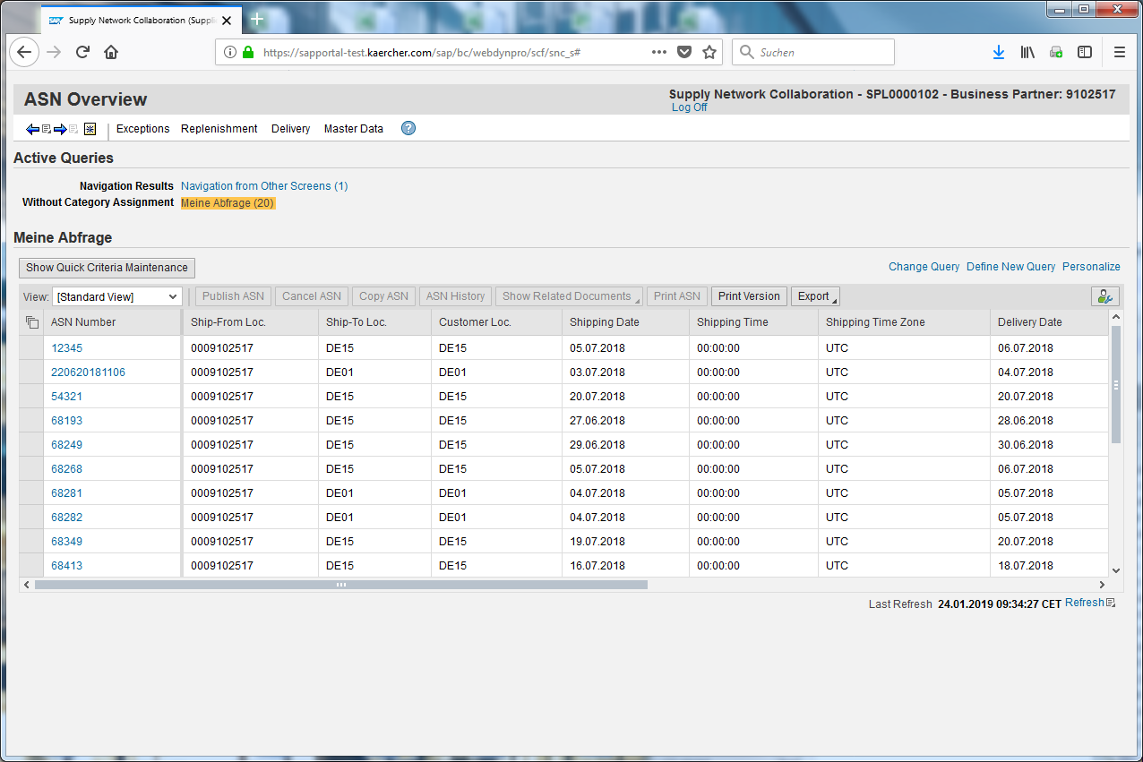
Click the Define New Query input field.
Every selected ASN is shown in this list. Now you can create your own selection and save it for later.
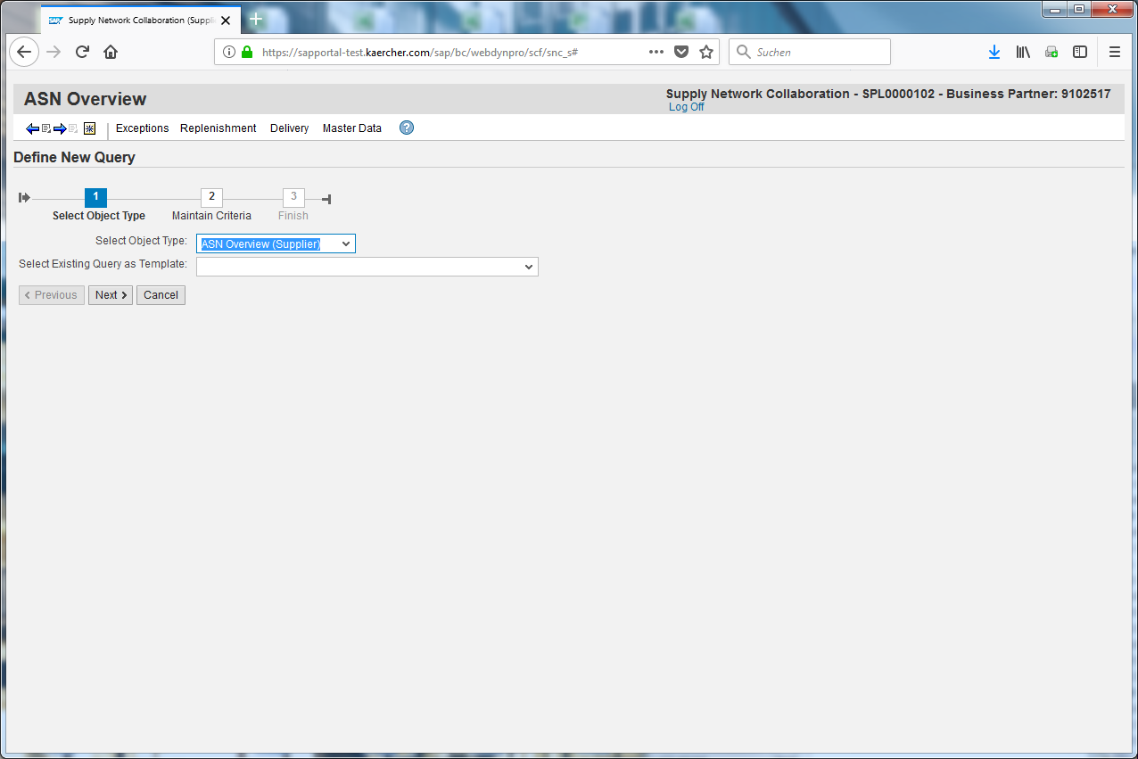
Click .
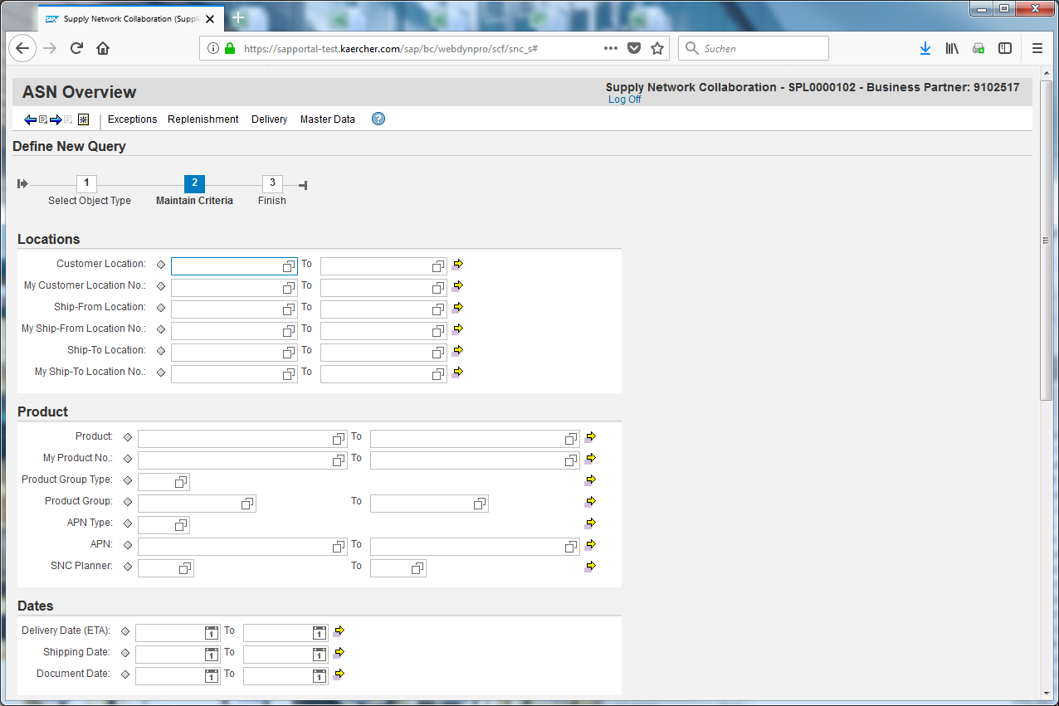
Click the Advanced Options image.
Define your parameters like for example the Customer Location.
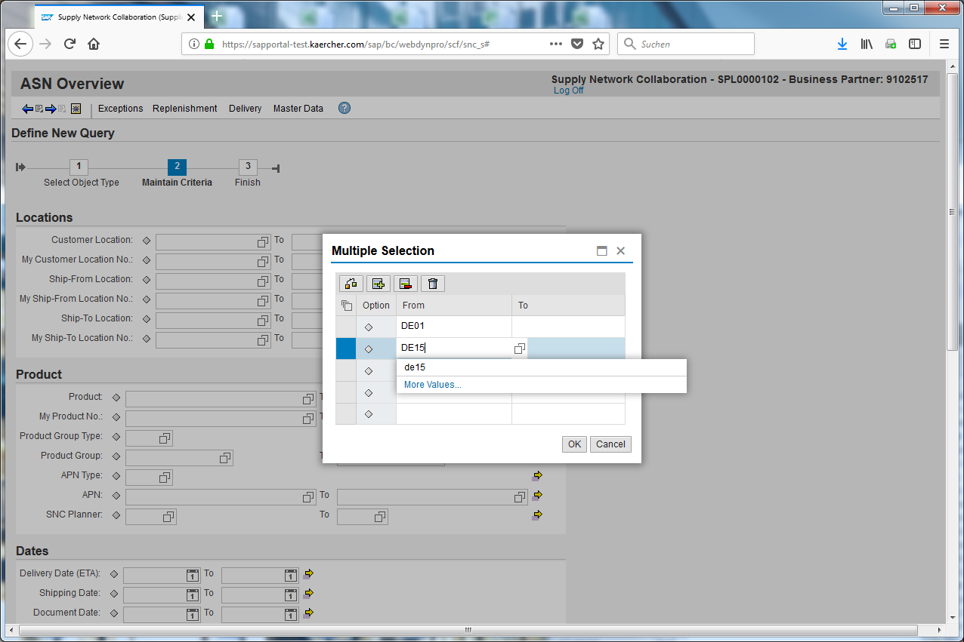
Click after you have inserted all values you need.
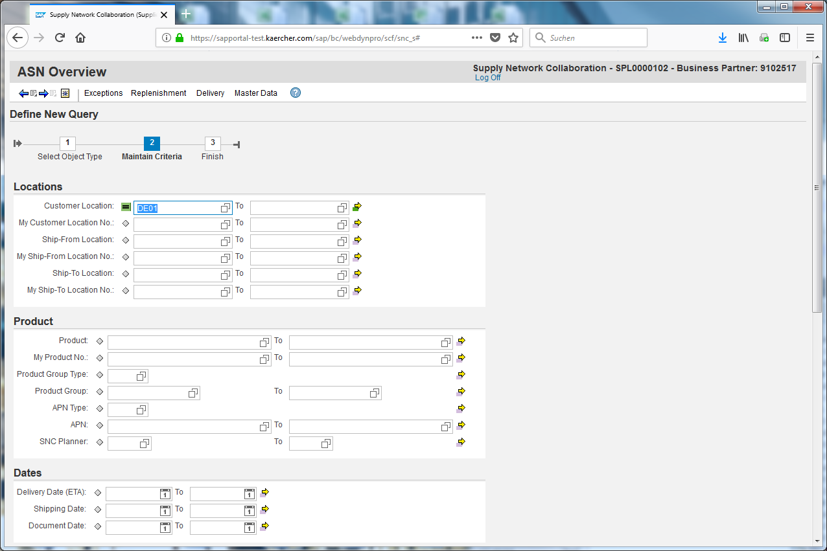
Scroll down.
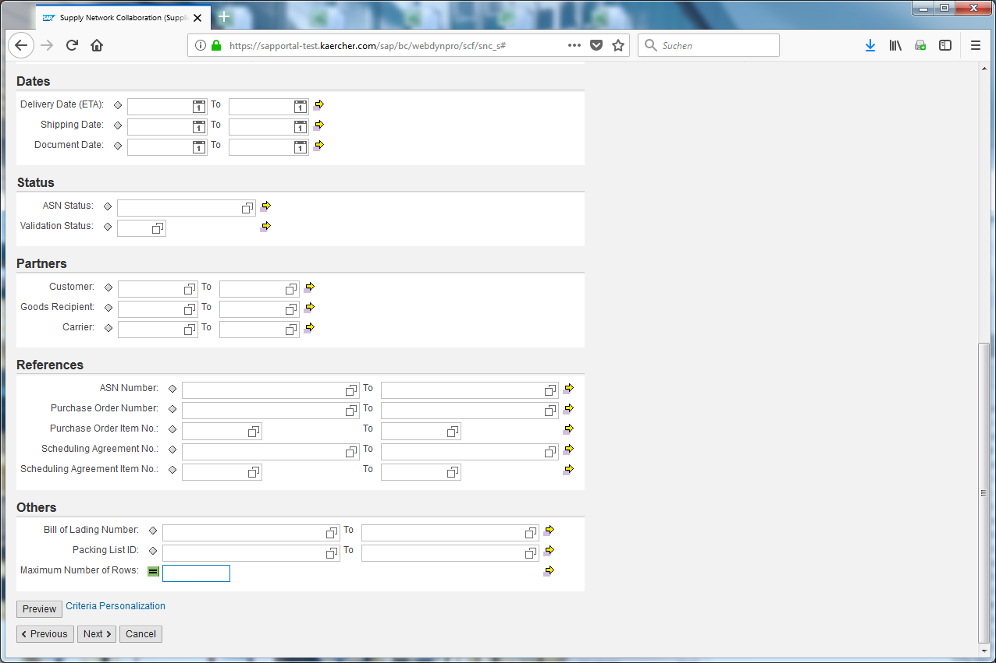
Delete the maximum number of rows to see all entries.
Click .
After all parameters are selected you can go on to save it.
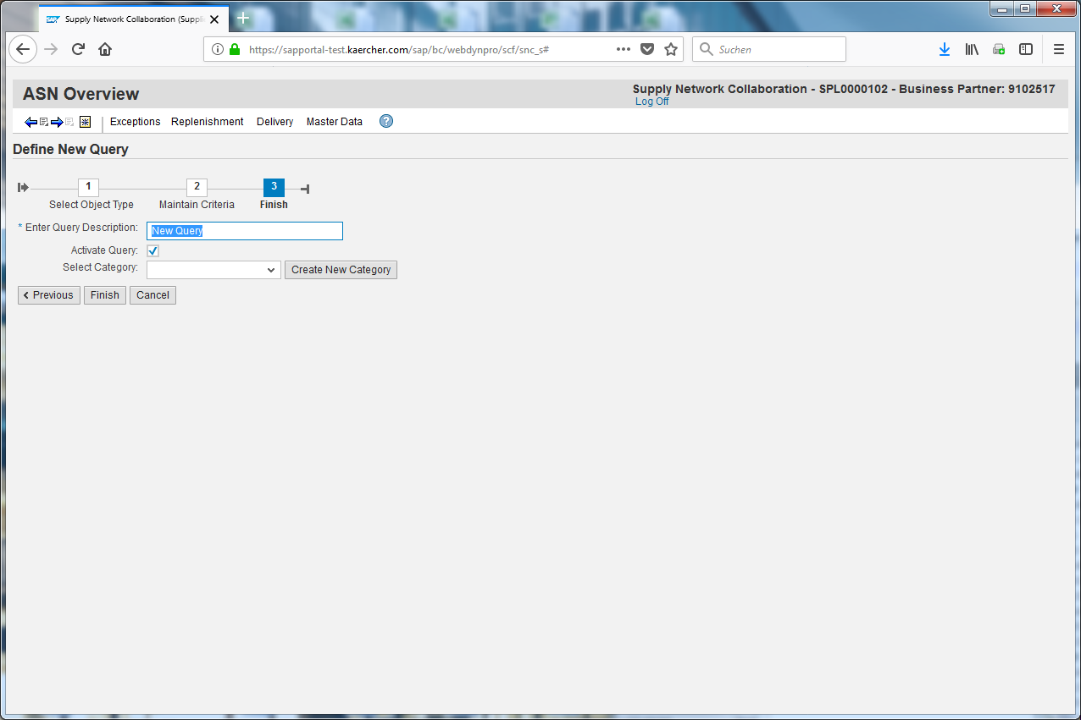
Insert a name for your query (test query).
Click .
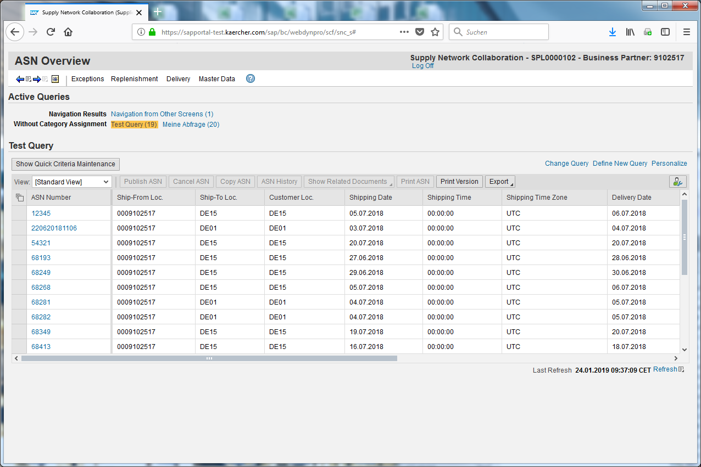
Your query will be shown shown here and can be selected when you need it.
Below you see all ASNs for the selected query.

