Select the replenishment order you want to deliver.
With CTRL-Key you can select different lines.
To create an ASN please use the query you have created before.
Click .
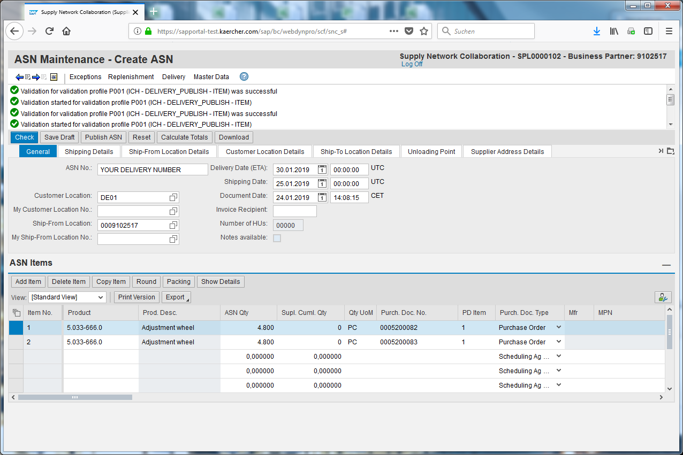
Enter your delivery number into the ASN Number field.
Click .
Click .
There should be no more errors after the check.
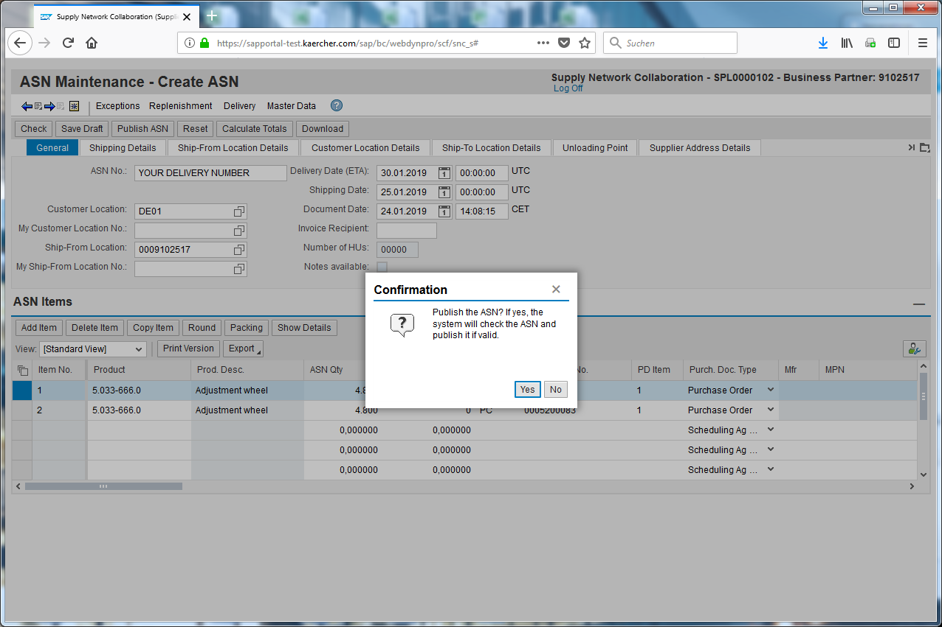
Click .
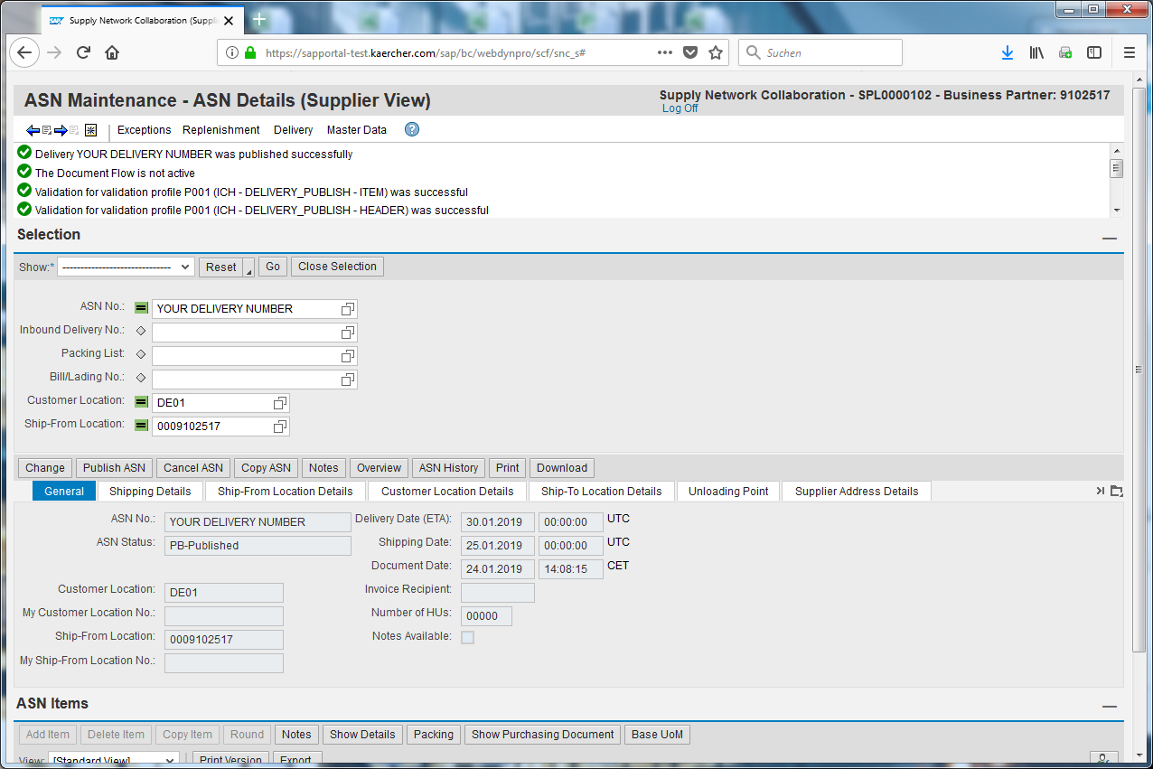
Check your Min/Max-Replenishment overview.
Your ASN has successfully been saved and published.
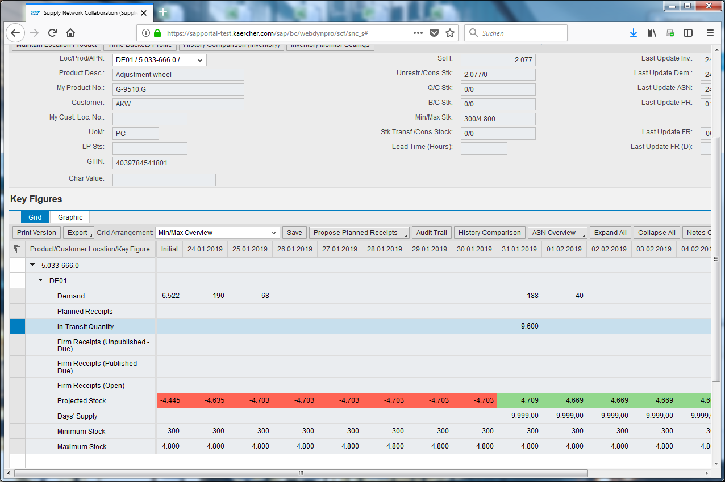
The Firm receipt has been changed to to In-Transit Quantity.
Take care that the delivery date has been changed from 30.01.2019 to 31.01.2019 because 30.01.2019 would be a Sunday.

