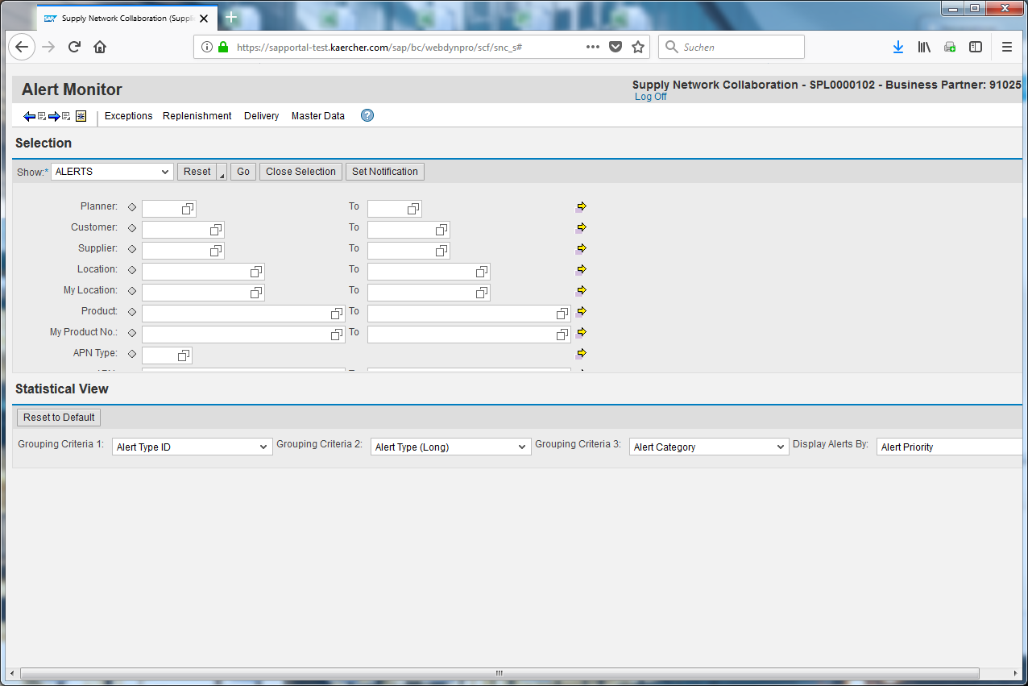
Click .
This E-Learning shows you how to create a Query in the due list to find all replenishment orders without an ASN.
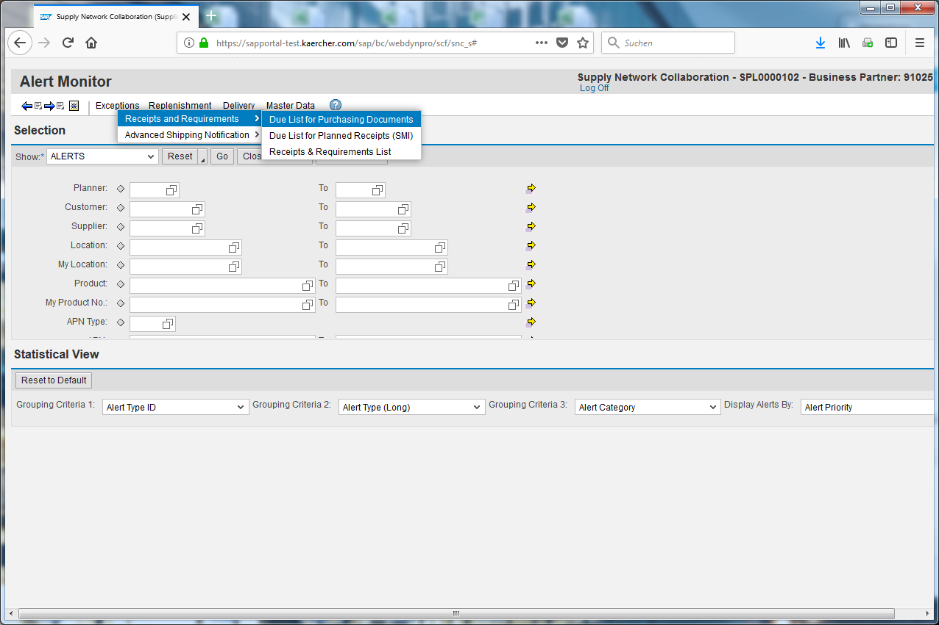
Click the table cell.
Click the Due List for Purchasing Documents input field.
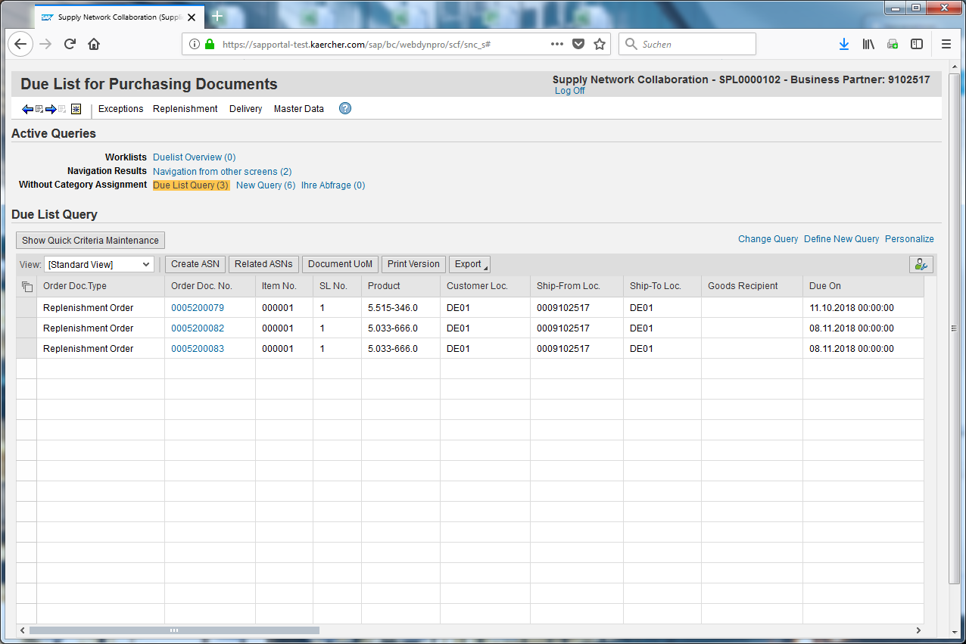
Click the Define New Query input field.
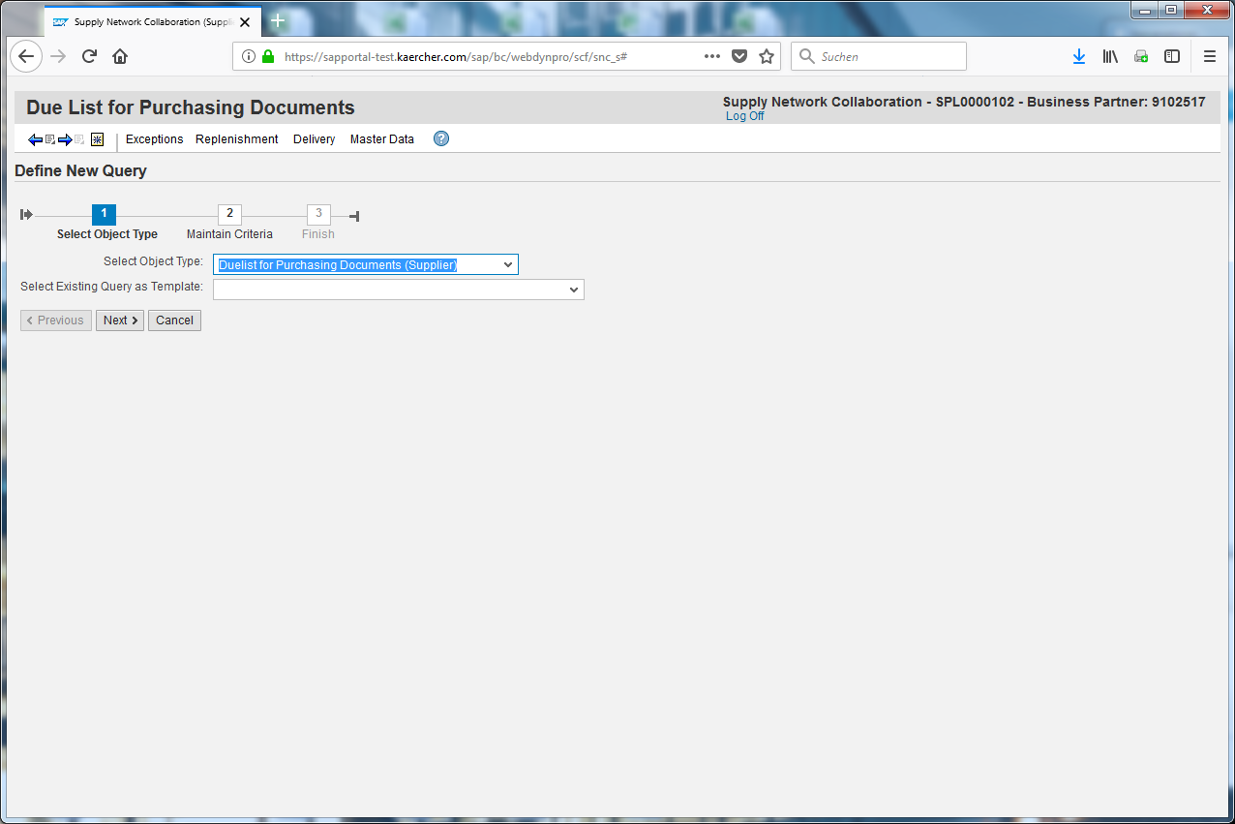
Click .
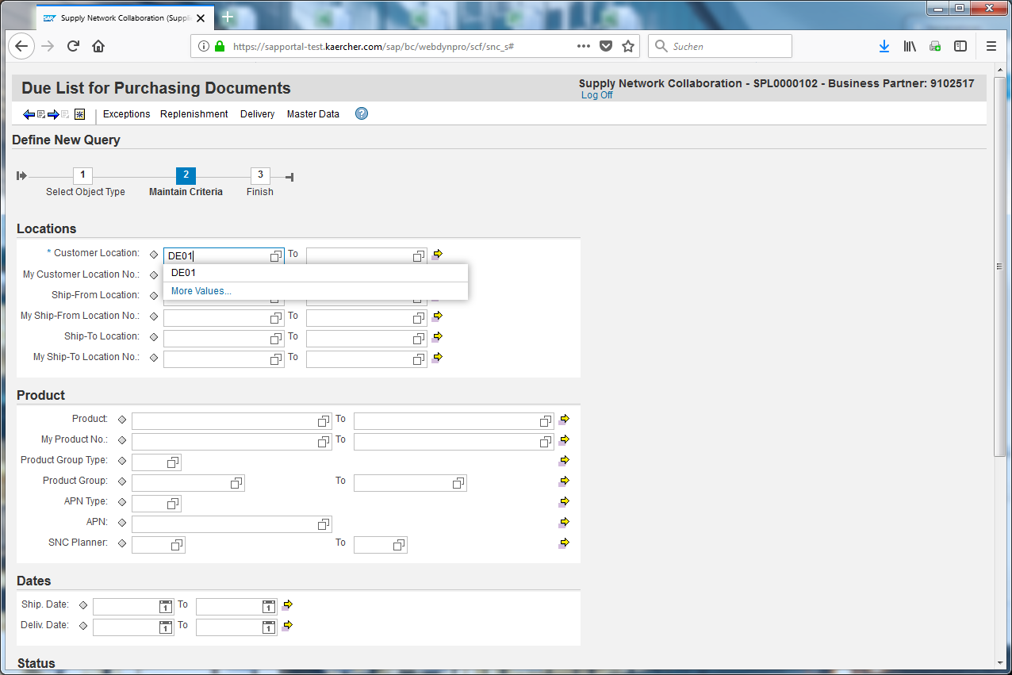
Define the parameters as you need and enter the values.
Please create for each customer location one Query.
Enter DE01 into the Number of Customer Location field.
Scroll down.
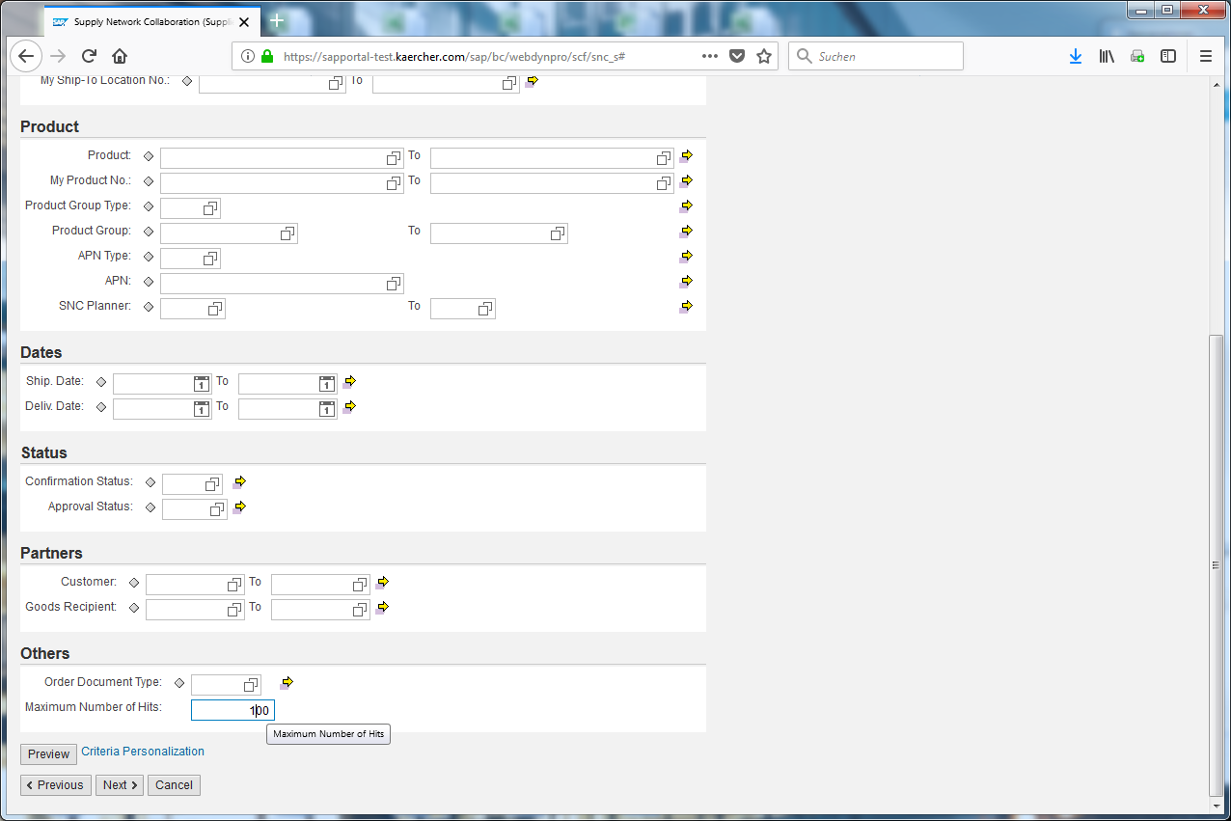
Click the Maximum Number of Hits input field.
You can add several criterias but you should delete the maximum number of hits to really find all entries.
Click .
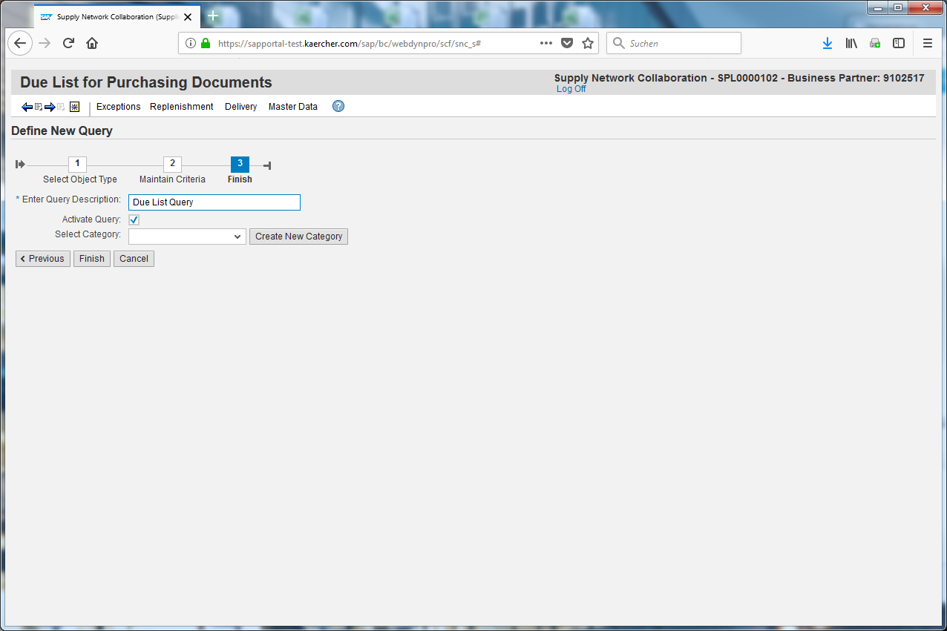
Insert a name to refind your query.
Click .
Your query has been added and can be chosen now.

